Traumatic Brain Injury (TBI)

Instruments User Manual



Version 5.8

April 2018

Department of Veterans Affairs

Office of Information and Technology (OIT)

Product Development

THIS PAGE IS INTENTIONALLY LEFT BLANK

Revision History

|  |  |  |  |
| --- | --- | --- | --- |
| Date | Version | Description | Author |
| 3/16/2018 | 5.8 | Added Rehabilitation and Reintegration Care Plan Report, All Patient Treatment Phase Outcome Report, and Patient Trent and Outcomes Report. | J. Reese  Mike Heath |
| 11/24/2017 | 5.7 | Updated document with new screens for PROMIS, PGIC, Optimal, Optimal Followup, and Rehab Follow Up. Updated other screens as appropriate. | J. Reese |
| 09/18/2017 | 5.6 | Updated document with PROMIS screens and new screens for PGIC and the Select Instruments screen. | J. Reese |
| 05/11/2017 | 5.5 | Updated manual and 508 compliance changes. | J. Reese |
| 11/3/2015 | 5.4 | Added Pyramid Analytic screenshots and updated screenshots with the latest GUI images | D. Hassell |
| 7/7/2015 | 5.3 | TBI Enhancements Increment 1 – Updated section 3.2 with new View Instruments Reports. | D. Hassell |
| 8/11/2014 | 5.2 | Updated to include Instruments screenshots and descriptions | T.Thweatt |
| 3/25/2014 | 5.1 | Included 11 Instrument screenshots and descriptions. | T. Thweatt |
| 6/4/2013 | 5.0 | Update to Registry Version 5.0 baseline | K. Jocius |
| 5/14/2012 | 4.0 | Increment 4 Final, approved manual | J. Sanders  S. Smith  D. Zaudtke |
| 5/10/2012 | 3.5 | Final Review | S. Smith |
| 5/9/2012 | 3.4 | Incorporated instrument business logic and sample CPRS reports. | D. Zaudtke |
| 5/7/2012 | 3.3 | Peer Review of Section 3.3 | S. Smith |
| 5/2/2012 | 3.2 | Incorporated Peer review comments | D. Zaudtke |
| 5/1/2012 | 3.1 | Peer Review | S. Smith |
| 4/25/2012 | 3.0 | Incorporated major revisions, updated for increment 4, added Preface section, Glossary, expanded TBI Follow Up Section | D. Zaudtke |
| 9/06/2011 | 1.2 | Incorporated minor revisions, edited screenshots | D. Zaudtke |
| 5/06/2011 | 1.1 | Incorporated Comments from Business Owner | J. Sanders; T. Delgado |
| 1/21/2011 | 1.0 | Final Version | T. Delgado; L. Berry |
| 1/20/2011 | 0.4 | Incorporate Comments | V. Dunie |
| 1/19/2011 | 0.3 | Peer Review | L. Berry |
| 1/15/2011 | 0.2 | Editorial Review | V. Dunie |
| 1/15/2011 | 0.1 | Draft Version | V. Dunie |

Table of Contents

[1. Preface 11](#_Toc508957769)

[1.1. Typographical Conventions Used in the Manual 11](#_Toc508957770)

[1.2. Command Buttons and Command Icons 11](#_Toc508957771)

[2. Background 12](#_Toc508957772)

[2.1. Related Documents 12](#_Toc508957773)

[3. Software Details 13](#_Toc508957774)

[3.1. Starting the Application 13](#_Toc508957775)

[3.2. Select Instrument Screen 13](#_Toc508957776)

[3.2.1. TBI View Instruments Reports 14](#_Toc508957777)

[3.2.1.1. TBI View Last Three Instruments Button 14](#_Toc508957778)

[3.2.1.2. TBI View All Instruments Button 15](#_Toc508957779)

[3.2.1.3. TBI View Notes Hyperlink 15](#_Toc508957780)

[3.2.2. TBI Instrument Associations 16](#_Toc508957781)

[3.2.3. Comprehensive TBI Evaluation 22](#_Toc508957782)

[3.2.4. TBI Follow-Up Assessment Screen 39](#_Toc508957783)

[3.2.5. Mayo-Portland Adaptability Inventory (MPAI) 50](#_Toc508957784)

[3.3. Participation Index (M2PI) 55](#_Toc508957785)

[3.3.1. Rehabilitation and Reintegration Plan 56](#_Toc508957786)

[3.3.2. Rehabilitation Follow Up Instrument 61](#_Toc508957787)

[3.3.3. 2 Minute Walk Test 62](#_Toc508957788)

[3.3.4. L – Test 63](#_Toc508957789)

[3.3.5. Locomotor Capability Index – 5 (LCI – 5) 64](#_Toc508957790)

[3.3.6. Functional Mobility Assessment (FMA) 64](#_Toc508957791)

[3.3.7. OPTIMAL 1.1 Form 65](#_Toc508957792)

[3.3.8. OPTIMAL 1.1 Follow Up 67](#_Toc508957793)

[3.3.9. Quebec User Evaluation of Satisfaction with Assistive Technology (QUEST) 68](#_Toc508957794)

[3.3.10. VA Low Visual Functioning (LA LV VFQ 20) Survey 69](#_Toc508957795)

[3.3.11. Neurobehavioral Symptom Inventory (NSI) 70](#_Toc508957796)

[3.3.12. PROMIS - Pain Interference- Short Form 6a 71](#_Toc508957797)

[3.3.13. PROMIS – Upper Extremity - Short Form 7a 73](#_Toc508957798)

[3.3.14. PROMIS – Physical Function with Mobility Aid 75](#_Toc508957799)

[3.3.15. Patient Global Impression of Change (PGIC) 77](#_Toc508957800)

[3.3.16. Satisfaction with Life Scale (SWLS) 79](#_Toc508957801)

[3.3.17. Berg Balance Scale 80](#_Toc508957802)

[3.3.18. Disability Rating Scale (DRS) 81](#_Toc508957803)

[3.3.19. Participation Assessment with Recombined Tools – Objectives (PART-O) 82](#_Toc508957804)

[3.3.20. JFK Coma Recovery Scale 85](#_Toc508957805)

[3.3.21. Oswestry Disability 87](#_Toc508957806)

[3.3.22. Timed Up and Go 89](#_Toc508957807)

[3.3.23. Generalized Anxiety Disorder Scale (GAD-7) 89](#_Toc508957808)

[3.3.24. Post Traumatic Stress Disorder (PTSD) Checklist – Civilian Version (PCL-C) 90](#_Toc508957809)

[3.3.25. Patient Health Questionnaire – 9 (PHQ-9) 94](#_Toc508957810)

[3.3.26. Supervision Rating Scale (SRS) 96](#_Toc508957811)

[3.3.27. Insomnia Severity Index (ISI) 96](#_Toc508957812)

[3.3.28. Pain Outcomes Questionnaire VA Long Form – Intake 98](#_Toc508957813)

[3.3.29. Pain Outcomes Questionnaire VA Long Form – Discharge 100](#_Toc508957814)

[3.3.30. Pain Outcomes Questionnaire VA Long Form – Follow-Up 100](#_Toc508957815)

[3.3.31. World Health Organization - Disability Assessment Schedule (WHODAS 2.0) Interview 101](#_Toc508957816)

[3.3.32. World Health Organization - Disability Assessment Schedule (WHODAS 2.0) Self 101](#_Toc508957817)

[3.3.33. World Health Organization - Disability Assessment Schedule (WHODAS 2.0) PROXY 101](#_Toc508957818)

[3.4. Reporting 101](#_Toc508957819)

[3.4.1. Rehabilitation and Reintegration Care Plan Report 101](#_Toc508957820)

[3.4.2. All Patient Treatment Phase Outcome Report 103](#_Toc508957821)

[3.4.3. Patient Comprehensive Trend and Outcomes Report 104](#_Toc508957822)

[3.4.4. Individual Instrument Reports 106](#_Toc508957823)

[3.4.5. Analytics Reporting 107](#_Toc508957824)

[A. Business Rules 115](#_Toc508957825)

[A.1. Comprehensive TBI Evaluation Business Rules 115](#_Toc508957826)

[A.2. TBI Follow-up Evaluation Instrument Business Rules 120](#_Toc508957827)

[B. Glossary 122](#_Toc508957828)

[C. Web Based Application Elements 127](#_Toc508957829)

Table of Tables

[Table 1 – Typographical Conventions 11](#_Toc508957830)

[Table 2 – Graphical Conventions 11](#_Toc508957831)

[Table 3 – Comprehensive TBI Evaluation Business Rules 115](#_Toc508957832)

[Table 4 – TBI Evaluation Instrument Business Rules 120](#_Toc508957833)

Table of Figures

[Figure 1 – View Instruments / Select Instrument 14](#_Toc508957834)

[Figure 2 – Last Three Instruments Report 15](#_Toc508957835)

[Figure 3 – All Instruments Report 15](#_Toc508957836)

[Figure 4 – View Notes Report 16](#_Toc508957837)

[Figure 5 – Instrument Associations 17](#_Toc508957838)

[Figure 6 – Select Note Drop-Down Box 18](#_Toc508957839)

[Figure 7 – Link to Consult 19](#_Toc508957840)

[Figure 8 – Instrument Associations > Link to Encounter 20](#_Toc508957841)

[Figure 9 – Select Hospital Admission 20](#_Toc508957842)

[Figure 10 – Current Stay 21](#_Toc508957843)

[Figure 11 – Unscheduled or New Visit 21](#_Toc508957844)

[Figure 12 – Comprehensive TBI Evaluation Part 1 22](#_Toc508957845)

[Figure 13 – Comprehensive TBI Evaluation Part 2 23](#_Toc508957846)

[Figure 14 – Comprehensive TBI Evaluation Part 3 24](#_Toc508957847)

[Figure 15 – Comprehensive TBI Evaluation Part 4 25](#_Toc508957848)

[Figure 16 – Comprehensive TBI Evaluation Part 5 26](#_Toc508957849)

[Figure 17 – Comprehensive TBI Evaluation Part 6 27](#_Toc508957850)

[Figure 18 – Comprehensive TBI Evaluation Part 7 28](#_Toc508957851)

[Figure 19 – Comprehensive TBI Evaluation Part 8 29](#_Toc508957852)

[Figure 20 – Comprehensive TBI Evaluation Part 9 30](#_Toc508957853)

[Figure 21 – Comprehensive TBI Evaluation Part 10 31](#_Toc508957854)

[Figure 22 – Comprehensive TBI Evaluation Part 11 32](#_Toc508957855)

[Figure 23 – Comprehensive TBI Evaluation Part 12 33](#_Toc508957856)

[Figure 24 – Comprehensive TBI Evaluation Part 13 34](#_Toc508957857)

[Figure 25 – Comprehensive TBI Evaluation Part 14 35](#_Toc508957858)

[Figure 26 – Comprehensive TBI Evaluation Part 15 36](#_Toc508957859)

[Figure 27 – Comprehensive TBI Evaluation Part 16 37](#_Toc508957860)

[Figure 28 – TBI Follow-Up Assessment Screen Part 1 39](#_Toc508957861)

[Figure 29 – TBI Follow-Up Assessment Screen Part 2 40](#_Toc508957862)

[Figure 30 – TBI Follow-Up Assessment Screen Part 3 41](#_Toc508957863)

[Figure 31 – TBI Follow-Up Assessment Screen Part 4 42](#_Toc508957864)

[Figure 32 – TBI Follow-Up Assessment Screen Part 5 43](#_Toc508957865)

[Figure 33 – TBI Follow-Up Assessment Screen Part 6 44](#_Toc508957866)

[Figure 34 – TBI Follow-Up Assessment Screen Part 7 45](#_Toc508957867)

[Figure 35 – TBI Follow-Up Assessment Screen Part 8 46](#_Toc508957868)

[Figure 36 – TBI Follow-Up Assessment Screen Part 9 47](#_Toc508957869)

[Figure 37 – TBI Follow-Up Assessment Screen Part 10 48](#_Toc508957870)

[Figure 38 – Mayo Portland Adaptability Inventory (Part 1) 51](#_Toc508957871)

[Figure 39 – Mayo Portland Adaptability Inventory (Part 2) 52](#_Toc508957872)

[Figure 40 – Mayo Portland Adaptability Inventory (Part 3) 53](#_Toc508957873)

[Figure 41 – Mayo Portland Adaptability Inventory (Part 4) 54](#_Toc508957874)

[Figure 42 - Participation Index (M2PI) Instrument 55](#_Toc508957875)

[Figure 43 – Rehabilitation and Reintegration Plan Part 1 57](#_Toc508957876)

[Figure 44 – Rehabilitation and Reintegration Plan Part 2 58](#_Toc508957877)

[Figure 45 – Rehabilitation and Reintegration Plan Part 3 59](#_Toc508957878)

[Figure 46 – Rehabilitation and Reintegration Plan Part 4 60](#_Toc508957879)

[Figure 47 - Rehabilitation Follow Up Screen 61](#_Toc508957880)

[Figure 48 – 2 Minute Walk Test 62](#_Toc508957881)

[Figure 49 – L - Test 63](#_Toc508957882)

[Figure 50 – Locomotor Capability Index – 5 (LCI – 5) 64](#_Toc508957883)

[Figure 51 - Locomotor Capability Index 5 (Part 2) 64](#_Toc508957884)

[Figure 52 – Functional Mobility Assessment (FMA) 65](#_Toc508957885)

[Figure 53 - Optimal 1.1 Instrument Screen (Part 1) 66](#_Toc508957886)

[Figure 54 - Optimal 1.1 Instrument Screen (Part 2) 66](#_Toc508957887)

[Figure 55 - Optimal 1.1 Instrument Screen (Part 3) 67](#_Toc508957888)

[Figure 56 - Optimal 1.1 Instrument Screen (Part 4) 67](#_Toc508957889)

[Figure 57 - OPTIMAL 1.1 Follow Up Screen (Part 1) 68](#_Toc508957890)

[Figure 58 -OPTIMAL 1.1 Follow Up Screen (Part 2) 68](#_Toc508957891)

[Figure 59 – Quebec User Evaluation of Satisfaction with Assistive Technology (QUEST) 69](#_Toc508957892)

[Figure 60 – VA Low Visual Functioning (LA LV VFQ 20) Survey 70](#_Toc508957893)

[Figure 61 - Neurobehavioral Symptom Inventory (NSI) 71](#_Toc508957894)

[Figure 62 - PROMIS - Pain Interference - Short Form 6a (Part 1) 72](#_Toc508957895)

[Figure 63 - PROMIS - Pain Interference - Short Form 6a (Part 2) 72](#_Toc508957896)

[Figure 64 - PROMIS - Upper Extremity - Short Form 7a (Part 1) 74](#_Toc508957897)

[Figure 65 - PROMIS - Upper Extremity - Short Form 7a (Part 2) 75](#_Toc508957898)

[Figure 66 - PROMIS – Physical Function with Mobility Aid 76](#_Toc508957899)

[Figure 67 - PROMIS – Physical Function with Mobility Aid (Part 2) 77](#_Toc508957900)

[Figure 68 - PROMIS – Physical Function with Mobility Aid (Part 3) 77](#_Toc508957901)

[Figure 69 – Patient Global Impression of Change (PGIC) (Part 1) 78](#_Toc508957902)

[Figure 70 - Patient Global Impression of Change (Part 2) 79](#_Toc508957903)

[Figure 71 – Satisfaction with Life Scale (SWLS) 80](#_Toc508957904)

[Figure 72 – Berg Balance Scale 81](#_Toc508957905)

[Figure 73 – Disability Rating Scale (DRS) 82](#_Toc508957906)

[Figure 74– Participation Assessment with Recombined Tools (PART-O) – 1 of 3 83](#_Toc508957907)

[Figure 75 – Participation Assessment with Recombined Tools (PART-O) – 2 of 3 84](#_Toc508957908)

[Figure 76 – Participation Assessment with Recombined Tools (PART-O) – 3 of 3 85](#_Toc508957909)

[Figure 77 - JFK Coma Recovery Scale - Revised (CRS-R) 86](#_Toc508957910)

[Figure 78 - Oswestry Low Back Pain Disability Questionnaire – 1 of 2 88](#_Toc508957911)

[Figure 79 – Oswestry Low Back Pain Disability Questionnaire – 2 of 2 89](#_Toc508957912)

[Figure 80 - Generalized Anxiety Disorder Scale (GAD-7) 90](#_Toc508957913)

[Figure 81 – Post Traumatic Stress Disorder (PTSD) Checklist – Civilian Version (PCL-C) – 1 of 3 91](#_Toc508957914)

[Figure 82 – Post Traumatic Stress Disorder (PTSD) Checklist – Civilian Version (PCL-C) – 2 of 3 92](#_Toc508957915)

[Figure 83 – Post Traumatic Stress Disorder (PTSD) Checklist – Civilian Version (PCL-C) – 3 of 3 93](#_Toc508957916)

[Figure 84 – Post Traumatic Stress Disorder (PTSD) Checklist – Civilian Version (PCL-C) – 3 of 3 94](#_Toc508957917)

[Figure 85 – Patient Health Questionnaire – 9 (PHQ-9) – 1 of 2 95](#_Toc508957918)

[Figure 86 – Patient Health Questionnaire - 9 (PHQ-9) - 2 of 2 96](#_Toc508957919)

[Figure 87 – Insomnia Severity Index (ISI) – 1 of 2 97](#_Toc508957920)

[Figure 88 – Insomnia Severity Index (ISI) - 2 of 2 98](#_Toc508957921)

[Figure 89 – Pain Outcomes Questionnaire VA Long Form – Intake – 1 of 3 99](#_Toc508957922)

[Figure 90 – Pain Outcomes Questionnaire VA Long Form – Intake – 2 of 3 100](#_Toc508957923)

[Figure 91 – Pain Outcomes Questionnaire VA Long Form – Intake – 3 of 3 100](#_Toc508957924)

[Figure 92 - Rehabilitation and Reintegration Care Plan (Initial Screen) 102](#_Toc508957925)

[Figure 93 - Rehabilitation and Reintegration Care Plan Summary 102](#_Toc508957926)

[Figure 94 - Rehabilitation and Reintegration Care Plan List of Patients 103](#_Toc508957927)

[Figure 95 - Patient Treatment Phase Outcome Report (Initial Screen) 104](#_Toc508957928)

[Figure 96 - Patient Treatment Phase Outcome Report Results 104](#_Toc508957929)

[Figure 97 - Patient Comprehensive Trend and Outcomes Report (Initial Screen) 105](#_Toc508957930)

[Figure 98 - Patient Comprehensive Trend and Outcome Summary Report Results 106](#_Toc508957931)

[Figure 99 – Sample Report 106](#_Toc508957932)

[Figure 100 - TBI Reporting Dashboard 108](#_Toc508957933)

[Figure 101 – Counts by Question Response Report Definitions 108](#_Toc508957934)

[Figure 102 – Comprehensive TBI Exam Counts 1 109](#_Toc508957935)

[Figure 103 – Comprehensive TBI Exam Counts 2 109](#_Toc508957936)

[Figure 104 – Counts by Clinical Presentation 111](#_Toc508957937)

[Figure 105 – Alteration of Conciousness Counts 111](#_Toc508957938)

[Figure 106 – Loss of Conciousness Counts 111](#_Toc508957939)

[Figure 107 – Post Traumatic Amnesia Counts 112](#_Toc508957940)

[Figure 108 – Mechanism of Injury Counts 112](#_Toc508957941)

[Figure 109 – Counts by Survey Type Report Definitions 113](#_Toc508957942)

[Figure 110 – Surveys by Gender Counts 113](#_Toc508957943)

[Figure 111 – OEF/OIF Counts 114](#_Toc508957944)

[Figure 112 – Surveys by Age Group Counts 114](#_Toc508957945)

[Figure 113 - Text Box Sample 1 128](#_Toc508957946)

[Figure 114 - Text Box Sample 2 128](#_Toc508957947)

[Figure 115 – Tool Tip for Text Box 128](#_Toc508957948)

[Figure 116 - Dropdown Sample 1 131](#_Toc508957949)

[Figure 117 - Dropdown Sample 2 131](#_Toc508957950)

1. **Preface**
   1. **Typographical Conventions Used in the Manual**

Throughout this document, the following fonts and other conventions are used:

**Table 1 – Typographical Conventions**

| **Font** | **Used for…** | **Examples:** |
| --- | --- | --- |
| Blue text, underlined | Hyperlink to another document or URL | [ftp.fo-slc.med.va.gov](ftp://ftp.fo-slc.med.va.gov/) |
| Green text, dotted underlining | Hyperlink within this document | See Release History for details. |
| Courier New | Patch names, VistA filenames | Patch names will be in this font |
| Franklin Gothic Demi | Keyboard keys  Web application panel, pane, tab, and button names | < F1 >, < Alt >, < L >  Other Registries panel  [Delete] button |
| Microsoft Sans Serif | Software Application names | Traumatic Brain Injury (TBI) |
| Microsoft Sans Serif bold | Registry names | **TBI** |
| Database field names | **Mode field** |
| Report names | **National Summary Report** |
| Organization and Agency Names | **DoD, VA** |
| Microsoft Sans Serif, 50% gray and italics | Read-only fields | *Procedures* |
| Times New Roman | Normal text | Information of particular interest |
| Times New Roman Italic | Text emphasis | “It is *very* important . . .” |
| National and International Standard names | *International Statistical Classification of Diseases and Related Health Problems* |
| Document names | *Traumatic Brain Injury (TBI) Registry User Manual* |

**Table 2 – Graphical Conventions**

| **Graphic** | **Used for…** |
| --- | --- |
| Image of pen icon used to signify information of particular interest. | Information of particular interest regarding the current subject matter. |
| Image of tips icon. | A tip or additional information that may be helpful to the user. |
| Image of warning icon. | A warning concerning the current subject matter. |
| Document icon used to indicate that there is history of a function or operation. | Information about the history of a function or operation; provided for reference only. |
| Optional icon used to indicate if a process or action is optional. | Indicates an action or process which is optional |
| Resource icon used to indicate that a resource is available. | Indicates a resource available either in this document or elsewhere |

* 1. **Command Buttons and Command Icons**

| **Button/Icon** | **Description** |
| --- | --- |
| sample command button [Save] | A command button initiates an action. It is a rectangular “3-dimensional” shape with a label that specifies what action will be performed when the button is clicked. |
| sample command button (Search) | Common examples are shown at left. Command buttons that end with three dots indicate that selecting the command may evoke a subsidiary window. |
| sample command icon (Save) | In some cases, a command icon performs the same function, but appears on the menu bar and has a plain, flat appearance. One example is shown at left. |
| sample command icon [Group Titles] | In the text of this document, both command button and command icon names appear inside square brackets. Examples: [Search], [Save]. |

1. **Background**

The Veterans Health Administration (VHA) is charged with supporting the Presidential Task Force on Returning Global War on Terror Heroes. The Task Force has stated in the *Global War on Terror (GWOT)* report (recommendation P-7) that the Department of Veterans Affairs (VA) shall “create a ‘Traumatic Brain Injury’ Surveillance Center and Registry to monitor returning service members who have possibly sustained head injury and thus may potentially have a traumatic brain injury in order to provide early medical intervention.”

The Traumatic Brain Injury (TBI) Registry software applications collect data on the population of Veterans who participated in Operation Enduring Freedom/Operation Iraqi Freedom (OEF/OIF). These individuals need to be seen within 30 days for a comprehensive evaluation. Each facility can produce local reports (information related to patients evaluated and treated in their system).

The TBI Instruments are a set of comprehensive evaluation questionnaires (initial and follow up) designed to provide rehabilitation professionals with a vehicle by which they can assess patients and collect patient information. The information collected from these instruments is electronically transferred and stored in the form of a medical progress note in the patient’s electronic record. This progress note can be retrieved through the Computerized Patient Record System (CPRS).

The set of TBI Instruments include the Comprehensive TBI Evaluation, TBI Follow-Up Assessment, The Mayo-Portland Adaptability Inventory (MPAI), and the Rehabilitation and Reintegration Plan.

* 1. **Related Documents**

Related documents include:

* TBI System Management Guide
* TBI Application User Manual
* TBI Installation Guide
* TBI Instruments User Manual
* TBI Polytrauma User Manual
* TBI Release Notes

1. **Software Details**
   1. **Starting the Application**

To start TBI Instruments, follow these steps:

1. Log into CPRS
2. On the tool bar, select Tools > TBI Instruments.

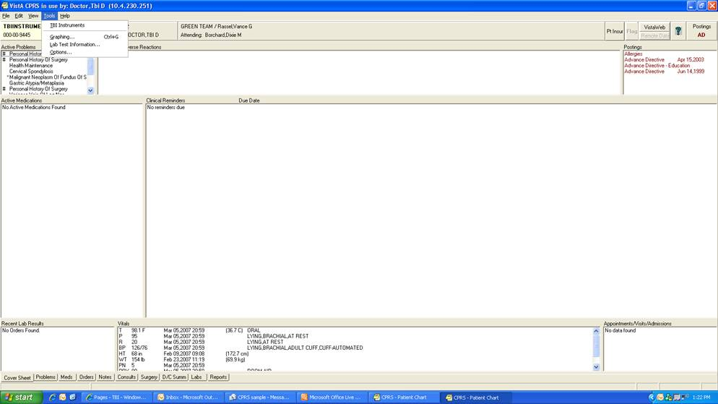

1. The TBI Instruments Patient Confirm page opens. This confirms the patient name and SSN match in the TBI Registry.
   1. **Select Instrument Screen**

The TBI Instruments > Confirm Patient and Select Instrument screen displays. Confirm the patient name and SSN match in the TBI Registry.

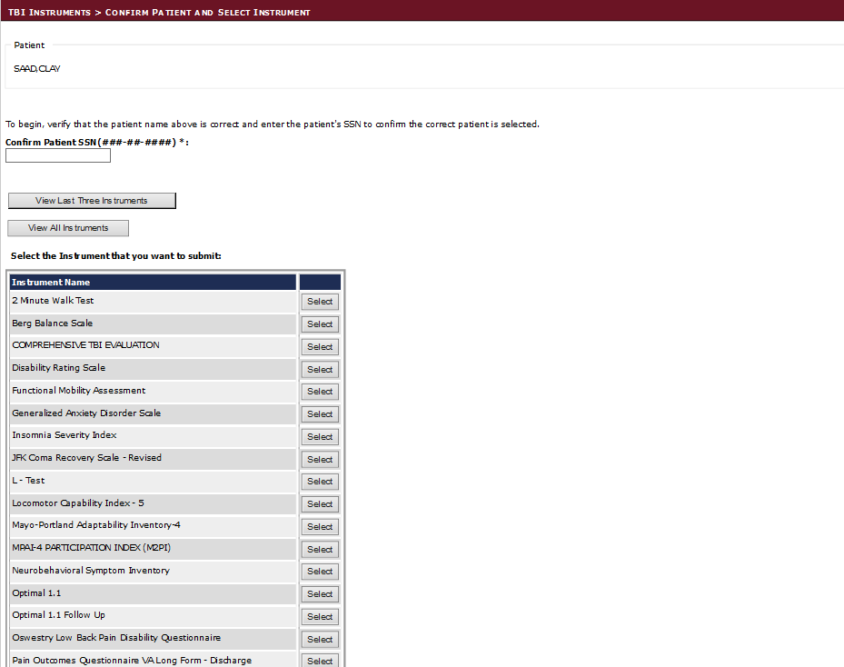

**Figure 1 – View Instruments / Select Instrument**

Click one of the View Instruments report buttons or select the appropriate Instrument you want to administer from the list by clicking the [Select] button.**TBI Instrument Association**

* + 1. **TBI View Instruments Reports**

The TBI Instruments > **View** Instrument Reports displays two buttons ‘View Last Three Instruments’ and ‘View All Instruments’ which link to reports for either the last three instruments on record or all of the instruments on record for that specific patient.

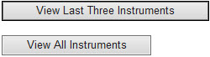

Both Pages offer a Standard Title Bar that can be used to Zoom, Search, Export, Refresh and Print Data from the pages. When on the View Notes Page a left hand arrow <- is enabled which allows the User to go back to the previous page versus the landing page.

****

The large  Back Button on the bottom of the pages always returns the user to the Landing Page in which they will need to re-type the patient’s Social Security Number to search for Instruments once again.

### TBI View Last Three Instruments Button

The TBI Instruments > View Last Three Instruments  displays the current patient’s last three TBI Instruments report.

**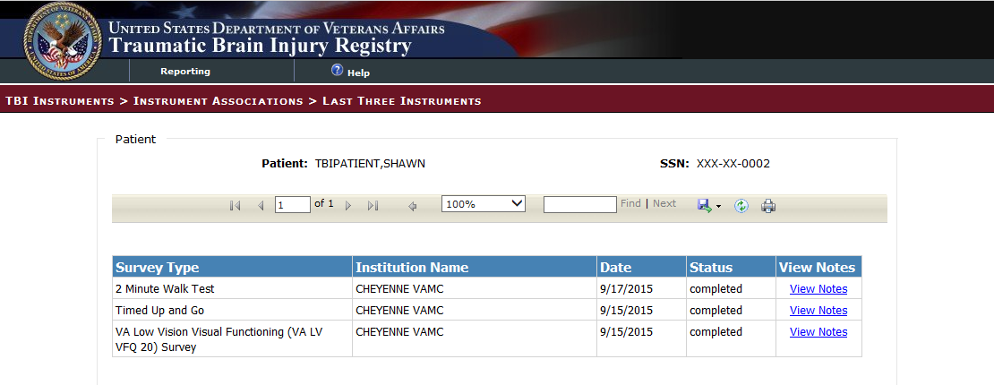**

**Figure 2 – Last Three Instruments Report**

### TBI View All Instruments Button

The TBI Instruments > View All Instruments  displays all the patient’s TBI Instruments report.

**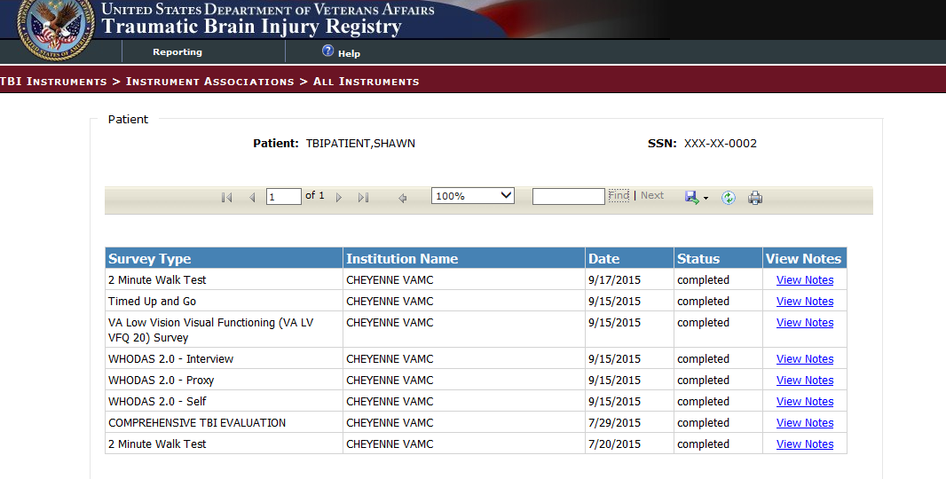**

**Figure 3 – All Instruments Report**

### TBI View Notes Hyperlink

The TBI Instruments > View Notes  displays the current patient’s TBI Survey Type notes details.

**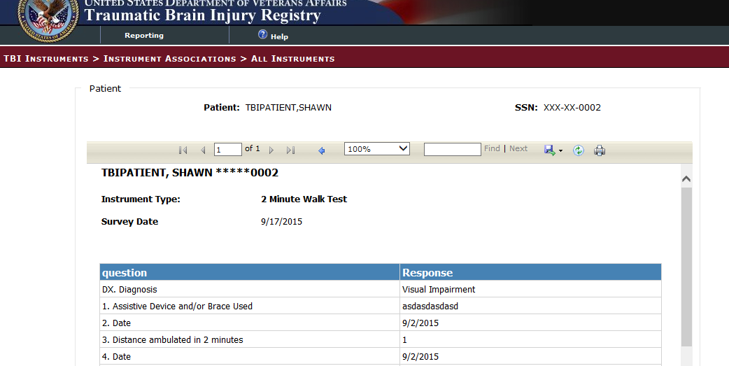**

**Figure 4 – View Notes Report**

* + 1. **TBI Instrument Associations**

The TBI Instruments > Instrument Associations screen displays. The patient name and the Instrument Type previously selected are presented on the screen.

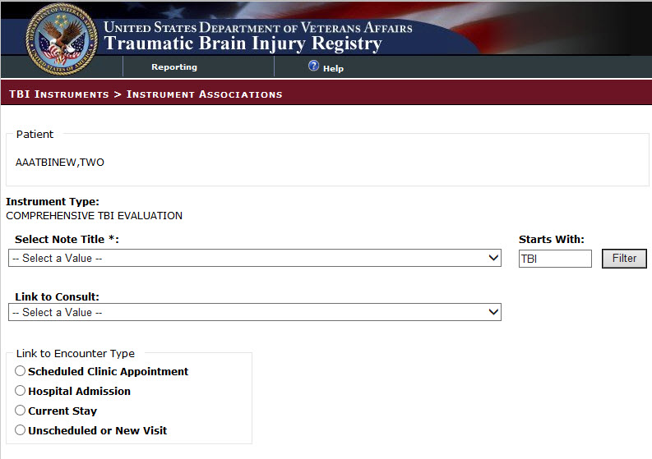

**Figure 5 – Instrument Associations**

Select an appropriate Note Title from the Select Note Title drop-down list. Appropriate Note Titles for TBI patients begin with TBI. This selection is required.

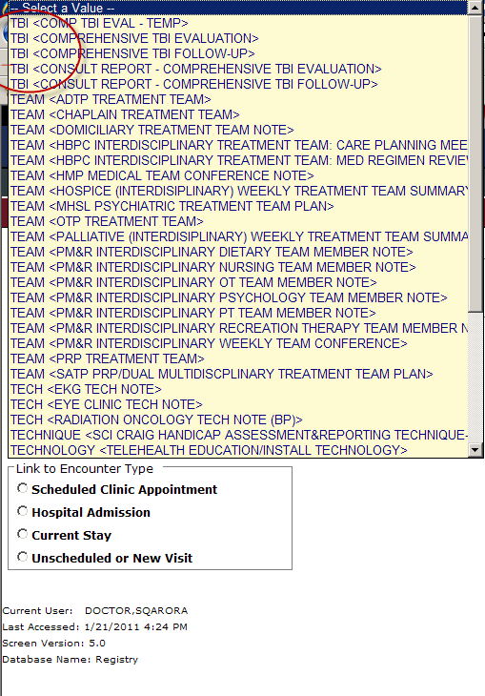

**Figure 6 – Select Note Drop-Down Box**

If the note title selected is classified as a ‘Consult Report’, the user entry will complete a consult in CPRS. Use the Link to Consult drop-down list to select the appropriate consult to which the entry should be linked in CPRS. While this selection is optional, the user must make a selection from the list in order for the consult report to be linked to a consult in CPRS.

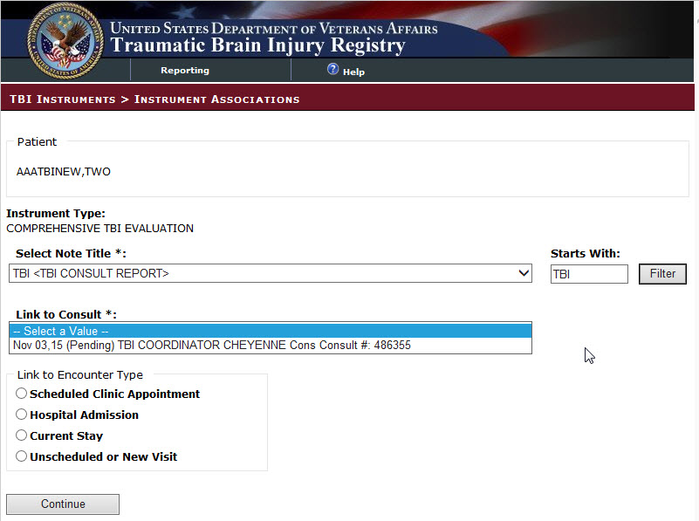

**Figure 7 – Link to Consult**

The Link to Consult drop-down list is populated with previously ordered consults for this patient. If the user selects a consult from the drop-down list, the data then entered via the selected TBI Instrument will be associated with the selected consult.

Use the radio button to select the appropriate Link to Encounter Type from the list.

If you select Scheduled Clinic Appointment, the application searches the period of time one month before today through one month after today. If any appointments are found, they are loaded into the Select the Scheduled Clinic Appointment drop down list. Select an appointment to proceed to the next step. If the user wishes to expand the date range for the search, the user can input new start and end dates and click Get Appointments and then proceed to the next step. This step associates the current instrument with the selected appointment.

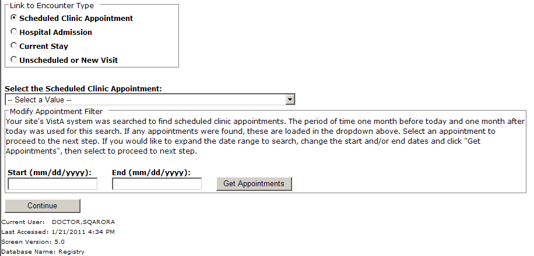

**Figure 8 – Instrument Associations > Link to Encounter**

If you select Hospital Admission, the application searches for previous hospital stays. If any are found, they are loaded into the Select the Hospital Admission drop down list, and the user can make the appropriate selection. If no previous stays are found for the patient, the user must select a different encounter type from the Link to Encounter Type list in order to proceed.

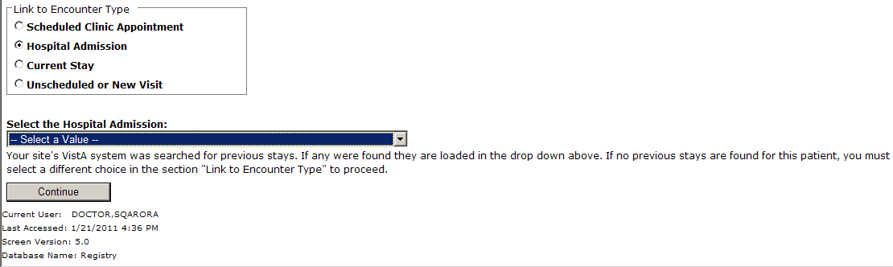

**Figure 9 – Select Hospital Admission**

If you select Current Stay, the next action required is to click [Continue] to move to the next screen.

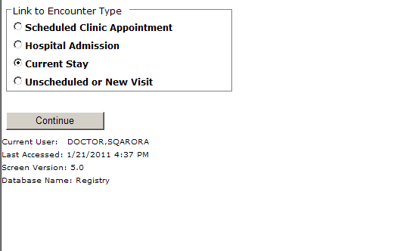

**Figure 10 – Current Stay**

If you select Unscheduled or New Visit, the application searches to find all locations at your site which begin with TBI. If any locations are found, they are loaded into the Location drop down list. If the user wants to search using a different location, the user can change the default search string and click [Get Locations]. After selecting a location, the user can click [Continue] to move to the next screen.

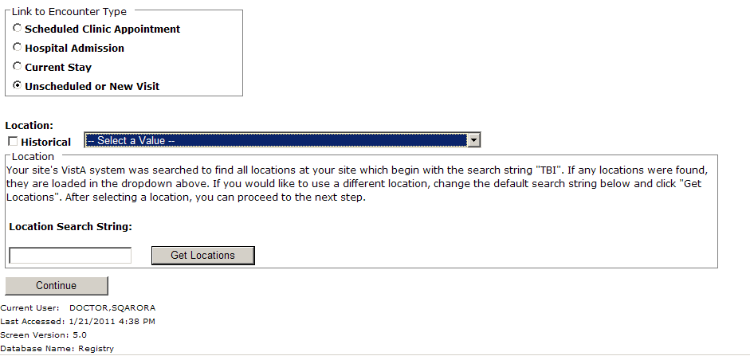

**Figure 11 – Unscheduled or New Visit**

* + 1. **Comprehensive TBI Evaluation**

The TBI Instruments > Comprehensive TBI Evaluation screen displays.

Select the appropriate answer for each patient.

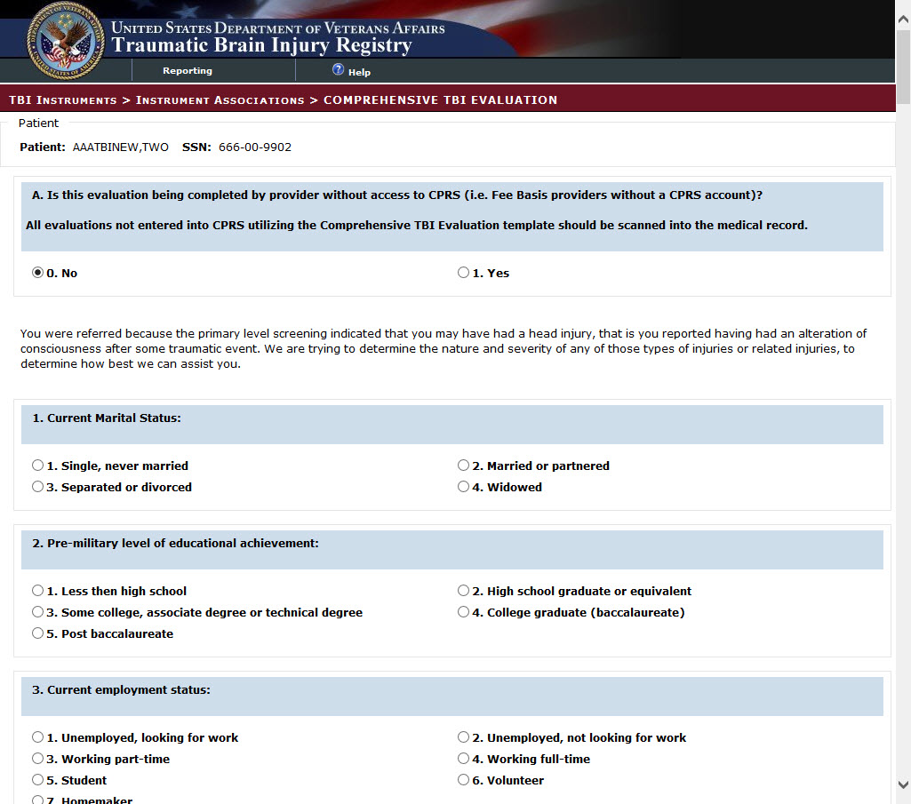

**Figure 12 – Comprehensive TBI Evaluation Part 1**

Image of Comprehensive TBI Evaluation Part 2

**Figure 13 – Comprehensive TBI Evaluation Part 2**

Image of Comprehensive TBI Evaluation Part 3

**Figure 14 – Comprehensive TBI Evaluation Part 3**

Image of Comprehensive TBI Evaluation Part 4

**Figure 15 – Comprehensive TBI Evaluation Part 4**

Image of Comprehensive TBI Evaluation Part 5

**Figure 16 – Comprehensive TBI Evaluation Part 5**

Image of Comprehensive TBI Evaluation Part 6

**Figure 17 – Comprehensive TBI Evaluation Part 6**

Image of Comprehensive TBI Evaluation Part 7

**Figure 18 – Comprehensive TBI Evaluation Part 7**

Image of Comprehensive TBI Evaluation Part 8

**Figure 19 – Comprehensive TBI Evaluation Part 8**

Image of Comprehensive TBI Evaluation Part 9

**Figure 20 – Comprehensive TBI Evaluation Part 9**

Image of Comprehensive TBI Evaluation Part 10

**Figure 21 – Comprehensive TBI Evaluation Part 10**

Image of Comprehensive TBI Evaluation Part 11

**Figure 22 – Comprehensive TBI Evaluation Part 11**

Image of Comprehensive TBI Evaluation Part 12

**Figure 23 – Comprehensive TBI Evaluation Part 12**

Image of Comprehensive TBI Evaluation Part 13

**Figure 24 – Comprehensive TBI Evaluation Part 13**

Image of Comprehensive TBI Evaluation Part 14

**Figure 25 – Comprehensive TBI Evaluation Part 14**

Image of Comprehensive TBI Evaluation Part 15

**Figure 26 – Comprehensive TBI Evaluation Part 15**

Image of Comprehensive TBI Evaluation Part 16Image of Comprehensive TBI Evaluation Part 16

**Figure 27 – Comprehensive TBI Evaluation Part 16**

Select [Save Draft] to save the information entered even if it is incomplete or in the event the user wishes to review the data again prior to completing the note.

Select [Save and Prepare Note] to preview the note.

Click [Cancel] to reset the questionnaire.

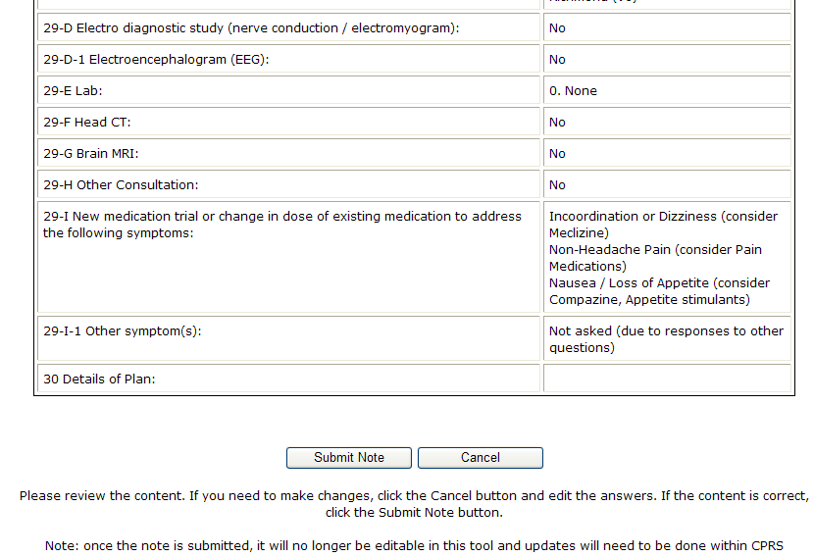

The application reformats the information entered into the questionnaire and displays the resulting report. The instructions on the screen suggest the user review the newly formatted content. If the user wants to make changes to the material, the user should click [Cancel] button and re-enter the answers. If the content is correct, the user clicks the [Submit Note] button.

Be aware that once the note is submitted, it is no longer editable within the TBI Instruments application and any updates will have to be made within CPRS.

The clinician must sign the note in CPRS.

* + 1. **TBI Follow-Up Assessment Screen**

The TBI Follow-Up Assessment questionnaire is similar to the Comprehensive TBI Evaluation. Select the appropriate response for each patient.

*Image of TBI Follow-Up Assessment Screen Part 1*

**Figure 28 – TBI Follow-Up Assessment Screen Part 1**

*Image of TBI Follow-Up Assessment Screen Part 2*

**Figure 29 – TBI Follow-Up Assessment Screen Part 2**

*Image of TBI Follow-Up Assessment Screen Part 3*

**Figure 30 – TBI Follow-Up Assessment Screen Part 3**

*Image of TBI Follow-Up Assessment Screen Part 4*

**Figure 31 – TBI Follow-Up Assessment Screen Part 4**

*Image of TBI Follow-Up Assessment Screen Part 5*

**Figure 32 – TBI Follow-Up Assessment Screen Part 5**

*Image of TBI Follow-Up Assessment Screen Part 6*

**Figure 33 – TBI Follow-Up Assessment Screen Part 6**

*Image of TBI Follow-Up Assessment Screen Part 7*

**Figure 34 – TBI Follow-Up Assessment Screen Part 7**

*Image of TBI Follow-Up Assessment Screen Part 8*

**Figure 35 – TBI Follow-Up Assessment Screen Part 8**

*Image of TBI Follow-Up Assessment Screen Part 9*

**Figure 36 – TBI Follow-Up Assessment Screen Part 9**

*Image of TBI Follow-Up Assessment Screen Part 10*

**Figure 37 – TBI Follow-Up Assessment Screen Part 10**

Select [Save Draft] to save the information entered even if it is incomplete or in the event the user wishes to review the data again prior to completing the note.

Select [Save and Prepare Note] to preview the note.

Click [Cancel] to reset the questionnaire.



The application reformats the information entered into the questionnaire and displays the resulting report. The instructions on the screen suggest the user review the newly formatted content. If the user wants to make changes to the material, the user should click [Cancel] button and re-enter the answers. If the content is correct, the user clicks the [Submit Note] button.

Be aware that once the note is submitted, it is no longer editable within the TBI Instruments application and any updates will have to be made within CPRS.

The clinician must sign the note in CPRS.

* + 1. **Mayo-Portland Adaptability Inventory (MPAI)**

MPAI was designed:

1. To assist in the clinical evaluation of people during the postacute (posthospital) period following acquired brain injury (ABI),
2. To assist in the evaluation of rehabilitation programs designed to serve these people, and
3. To better understand the long-term outcomes of ABI.

Evaluation and rating of each of the areas designated by MPAI items assures that the most frequent and important sequelae of ABI are considered for rehabilitation planning or other clinical interventions. MPAI items represent the range of physical, cognitive, emotional, behavioral, and social problems that people may encounter after ABI. MPAI items also provide an assessment of major obstacles to community integration which may result directly from ABI as well as problems in the social and physical environment. Periodic re-evaluation with MPAI during postacute rehabilitation or other intervention provides documentation of progress and of the efficacy and appropriateness of the intervention. Research that examines the responses to the MPAI by individuals with longstanding ABI and by their caregivers and close acquaintances helps to answer questions about the future of those who are newly injured, and their long-term medical, social and economic needs.

Select the appropriate response for each patient. All items are required, except where noted.

Image of Mayo Portland Adaptability Inventory Part 1

**Figure 38 – Mayo Portland Adaptability Inventory (Part 1)**

Image of Mayo Portland Adaptability Inventory Part 2

**Figure 39 – Mayo Portland Adaptability Inventory (Part 2)**

Image of Mayo Portland Adaptability Inventory Part 1

**Figure 40 – Mayo Portland Adaptability Inventory (Part 3)**

|  |  |
| --- | --- |
| Pen icon indicating a note. | * **Note:** You can only answer one of Item 7A or 7B. Refer to Figure 19 for the rest of item 7B. |

Image of Mayo Portland Adaptability Inventory Part 4

**Figure 41 – Mayo Portland Adaptability Inventory (Part 4)**

Select [Save Draft] to save the information entered even if it is incomplete or in the event the user wishes to review the data again prior to completing the note.

Select [Save and Prepare Note] to preview the note.

Click [Cancel] to reset the questionnaire.



The application reformats the information entered into the questionnaire and displays the resulting report. The instructions on the screen suggest the user review the newly formatted content. If the user wants to make changes to the material, the user should click [Cancel] button and re-enter the answers. If the content is correct, the user clicks the [Submit Note] button.

Be aware that once the note is submitted, it is no longer editable within the TBI Instruments application and any updates will have to be made within CPRS.

The clinician must sign the note in CPRS.

## Participation Index (M2PI)

The Participation Index (M2PI) instrument allows users to submit notes for patients who were previously entered in the PROMIS - Pain Interference- Short Form 6a, PROMIS – Upper Extremity - Short Form 7a, PROMIS – Physical Function with Mobility Aid, or Mayo-Portland Adaptability Inventory (MPAI) instruments.

After entering information for the patients in these instruments, providers must first create an Initial Note in M2PI. After the Initial Note is submitted, the provider may enter as many Interim notes as are required; however, they may only submit a single Discharge, and Follow Up note.

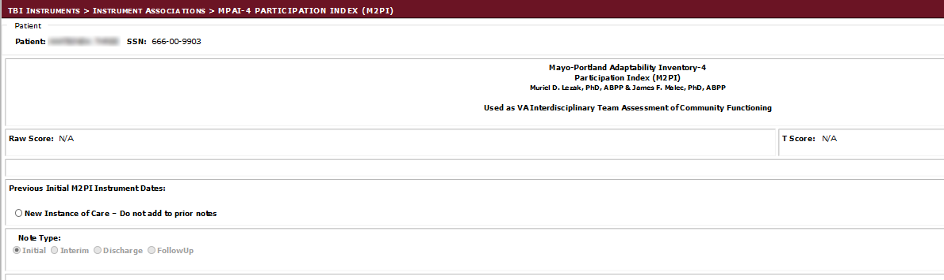

Figure 42 - Participation Index (M2PI) Instrument

### Rehabilitation and Reintegration Plan

The Rehabilitation and Community Reintegration Care plan also manages the ongoing and emerging rehabilitation and psychosocial needs of Veterans with polytrauma and TBI. This includes ongoing follow up and treatment, case management, coordination of services, monitoring the implementation of the treatment plan, overseeing the quality and intensity of VA and non-VA services, and providing education and support for patients and caregivers.

Select the appropriate response for each patient.

Image of Rehabilitation and Reintegration Plan Part 1

Figure 43 – Rehabilitation and Reintegration Plan Part 1

Image of Rehabilitation and Reintegration Plan Part 2

Figure 44 – Rehabilitation and Reintegration Plan Part 2

Image of Rehabilitation and Reintegration Plan Part 3

Figure 45 – Rehabilitation and Reintegration Plan Part 3

Image of Rehabilitation and Reintegration Plan Part 4

Figure 46 – Rehabilitation and Reintegration Plan Part 4

Select [Save Draft] to save the information entered even if it is incomplete or in the event the user wishes to review the data again prior to completing the note.

Select [Save and Prepare Note] to preview the note.

Click [Cancel] to reset the questionnaire.



The application reformats the information entered into the questionnaire and displays the resulting report. The instructions on the screen suggest the user review the newly formatted content. If the user wants to make changes to the material, the user should click [Cancel] button and re-enter the answers. If the content is correct, the user clicks the [Submit Note] button.

Be aware that once the note is submitted, it is no longer editable within the TBI Instruments application and any updates will have to be made within CPRS.

The clinician must sign the note in CPRS.

### Rehabilitation Follow Up Instrument

The Rehabilitation Follow Up instrument tracks patient feedback related to the rehabiliation they received in Inpatient or Outpatient facilities.

Select the appropriate response for each patient.

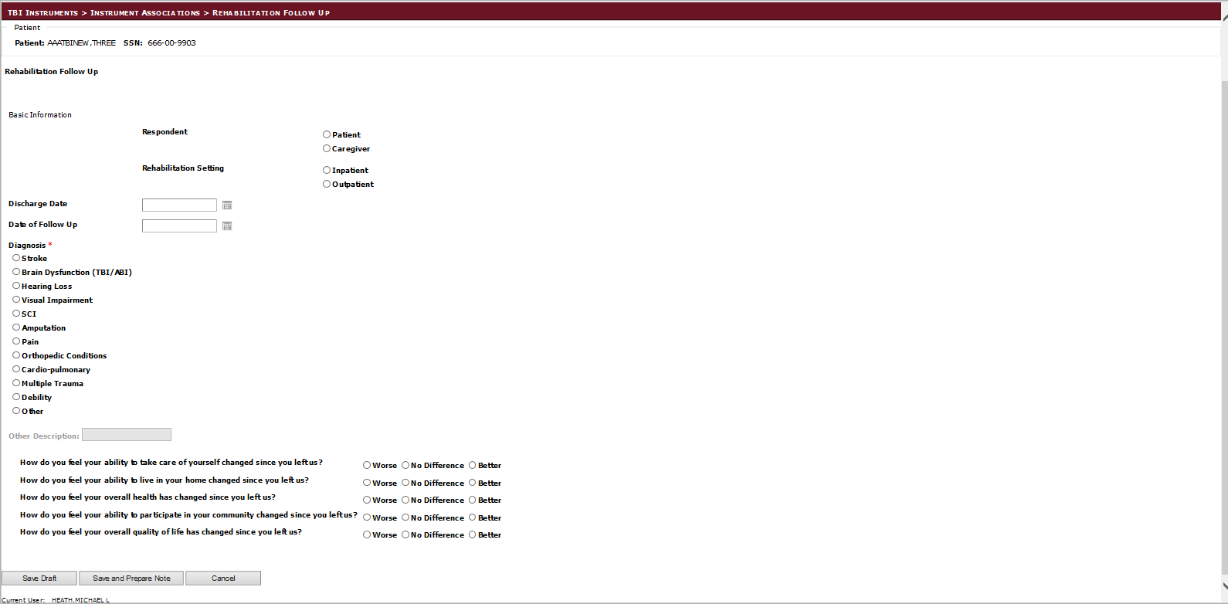

Figure 47 - Rehabilitation Follow Up Screen

### 2 Minute Walk Test

The 2-minute walking test is a useful and reproducible measure of exercise tolerance. It provides a simple, practical guide to everyday disability and does not require expensive apparatus.

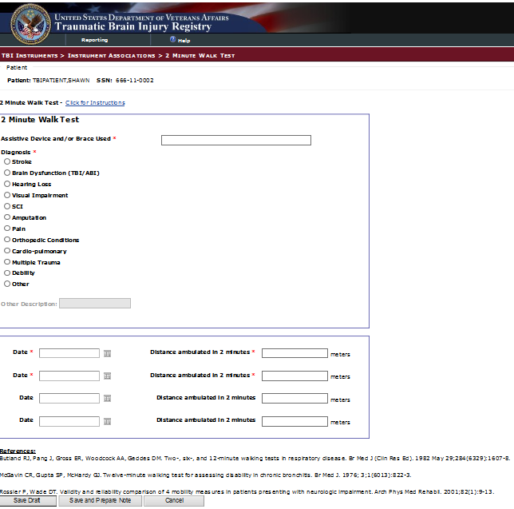

Figure 48 – 2 Minute Walk Test

### L – Test

The L-Test of Functional Mobility incorporates transfers and turns into an assessment of mobility and gait speed. Walk tests provide essential outcome information when assessing ambulation of individuals with lower-limb amputation and a prosthetic device.

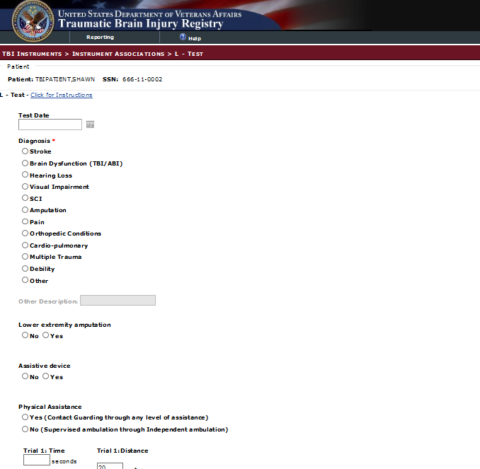

Figure 49 – L - Test

### Locomotor Capability Index – 5 (LCI – 5)

To assess the reliability, validity, and responsiveness of the Locomotor Capabilities Index (LCI) in people with lower-limb amputation who undergo prosthetic training, the LCI surveys face-to-face interviews.

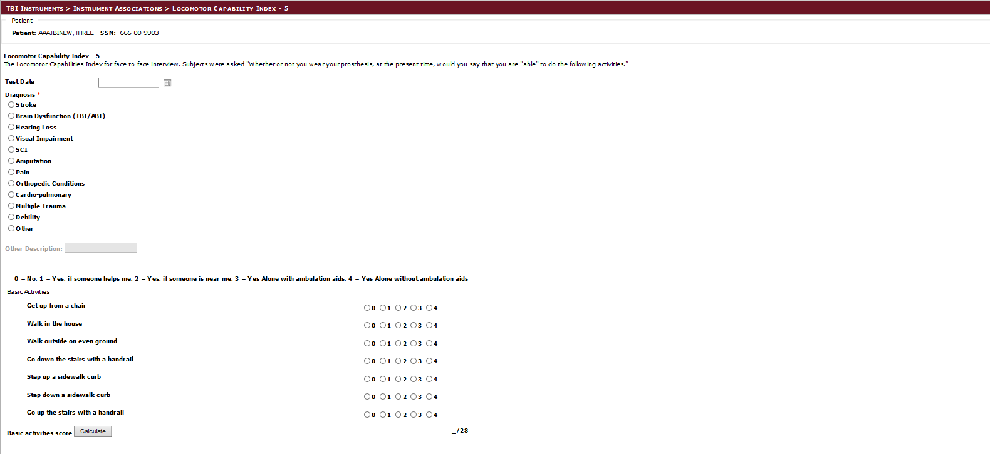

Figure 50 – Locomotor Capability Index – 5 (LCI – 5)

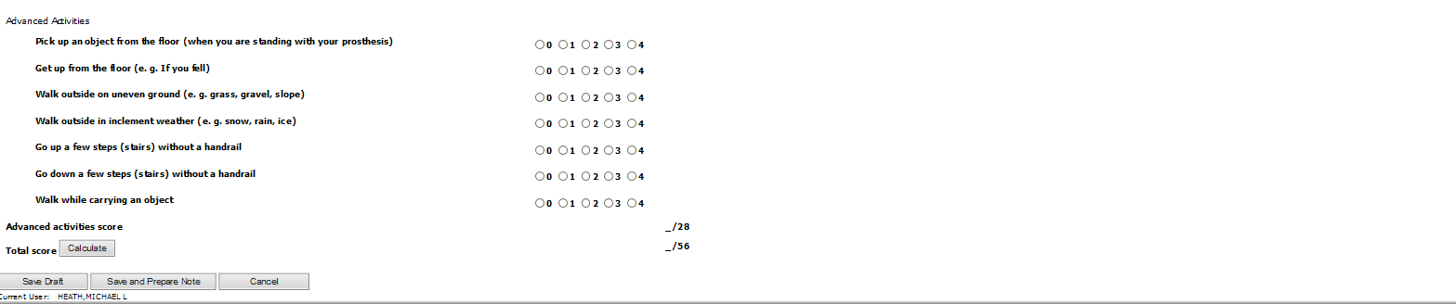

Figure 51 - Locomotor Capability Index 5 (Part 2)

### Functional Mobility Assessment (FMA)

The Functional Mobility Assessment (FMA) instrument is a self-report outcomes tool designed to measure effectiveness of wheeled mobility and seating (WMS) interventions for PWD. Functional mobility is necessary to perform activities of daily living and for community participation for everyone, but especially important for persons with disabilities (PWD). Therefore, functional mobility requires reliable measurement of consumer satisfaction and functional changes.

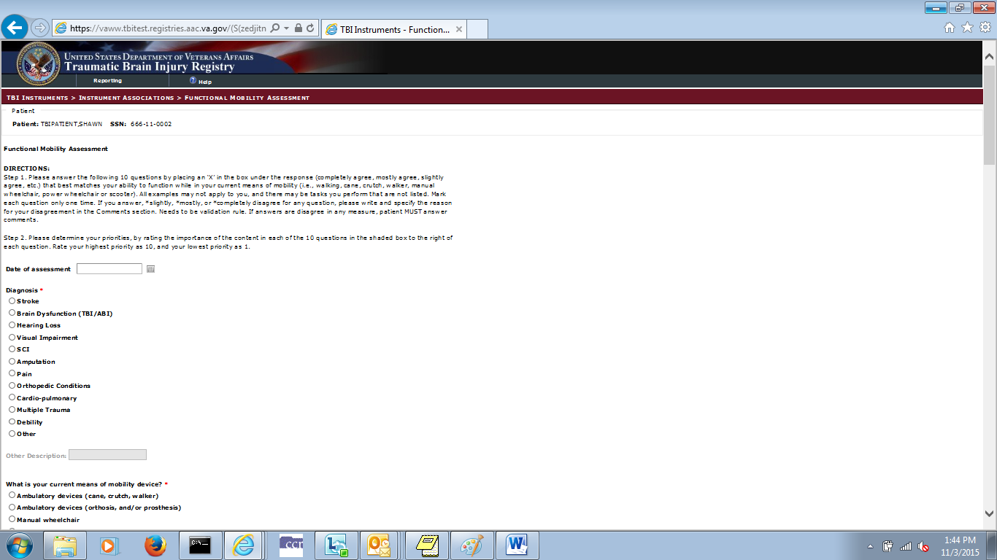

Figure 52 – Functional Mobility Assessment (FMA)

### OPTIMAL 1.1 Form

The Amerian Physical Therapy Association (APTA) uses the Outpatient Physical Therapy Improvement in Movement Assessment Log (OPTIMAL) as an instrument that measures difficulty and self-confidence in performing 22 movements that a patient/client needs to accomplish in order to do various functional activities. OPTIMAL 1.1 has been updated from the original version to increase clinical utility. This includes adding the clinically relevant item of standing and providing changes to scoring instructions to increase clinical utility. These changes assist patient and physical therapist discussion toward identifying the primary goal for the episode of care.

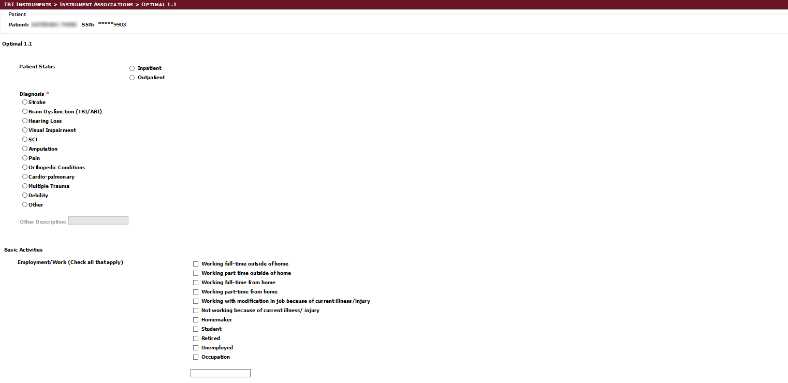

Figure 53 - Optimal 1.1 Instrument Screen (Part 1)

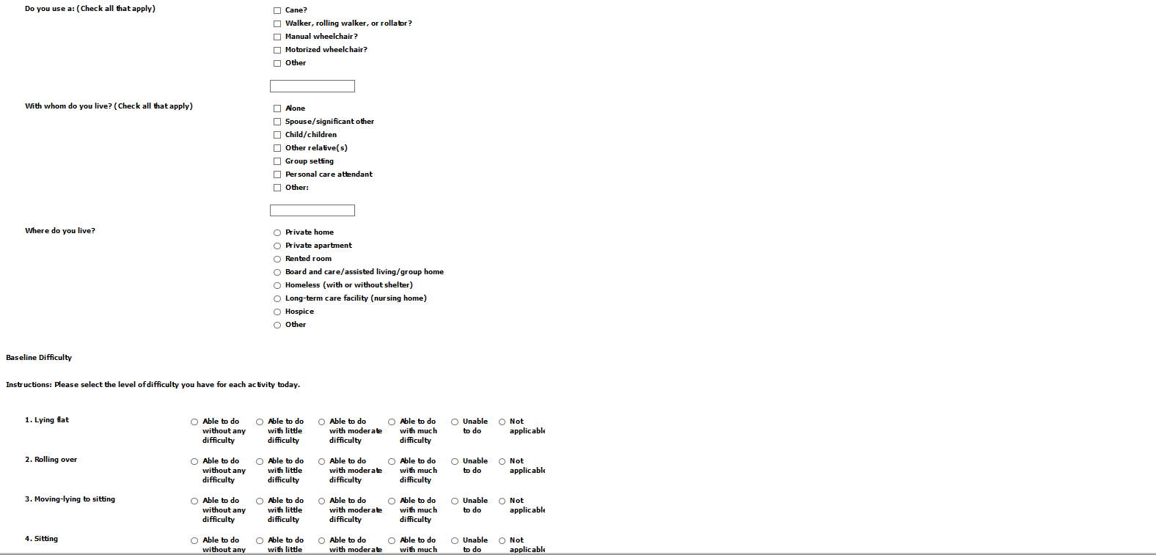

Figure 54 - Optimal 1.1 Instrument Screen (Part 2)

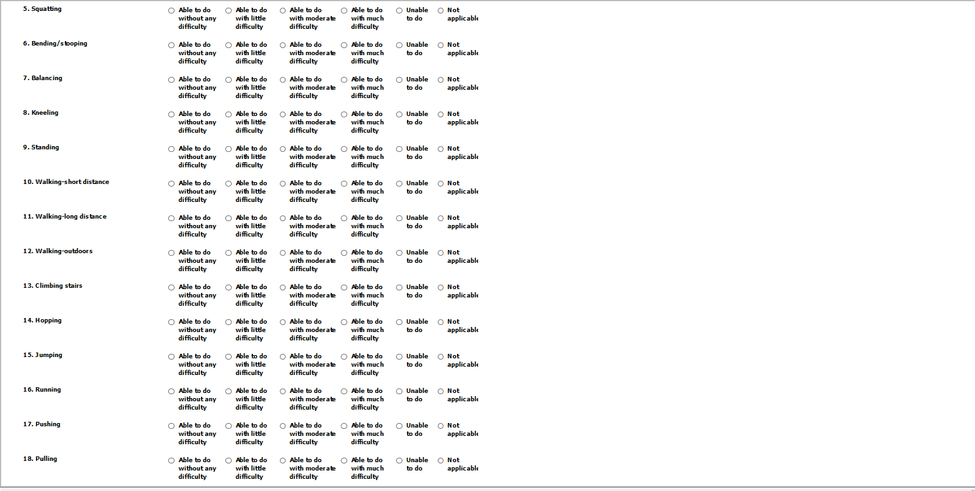

Figure 55 - Optimal 1.1 Instrument Screen (Part 3)

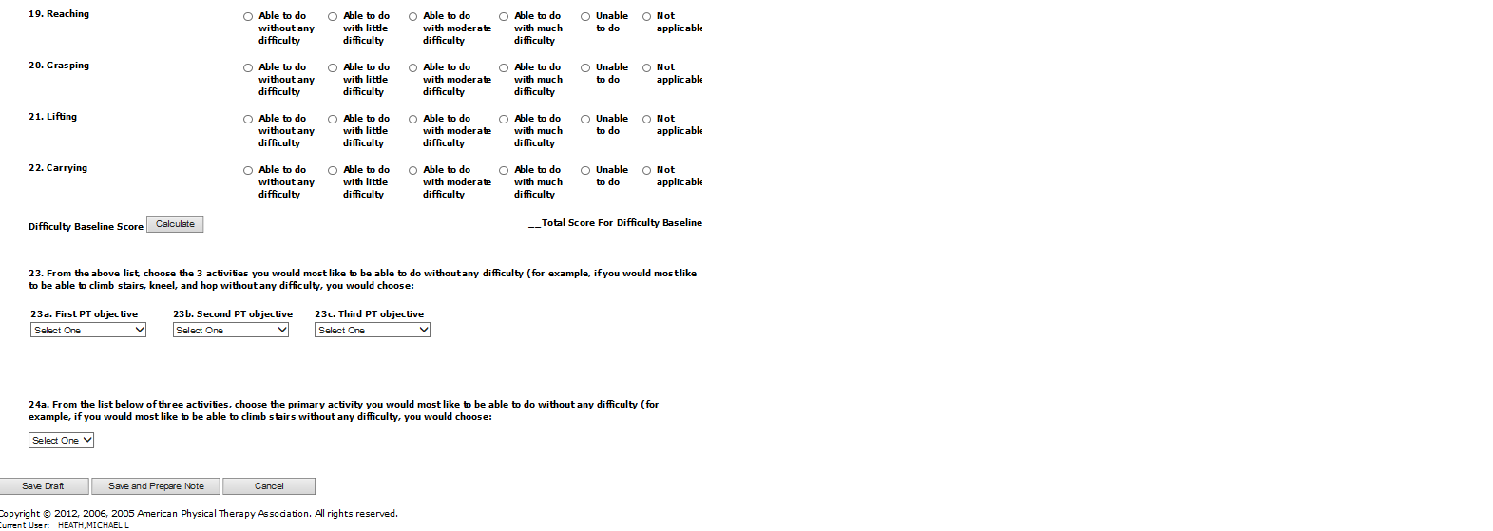

Figure 56 - Optimal 1.1 Instrument Screen (Part 4)

### OPTIMAL 1.1 Follow Up

The OPTIMAL 1.1 Follow Up instrument is used to collect follow up information in an effort to identify changes from the baseline assessment collected in the OPTIMAL 1.1 instrument.

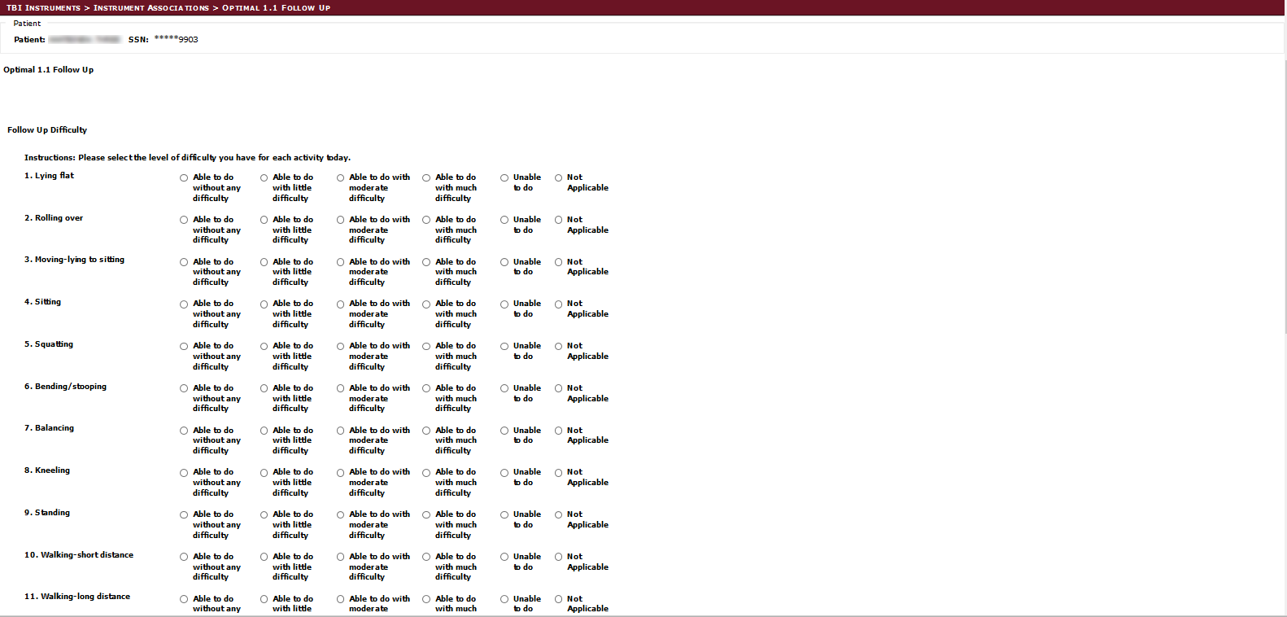

Figure 57 - OPTIMAL 1.1 Follow Up Screen (Part 1)

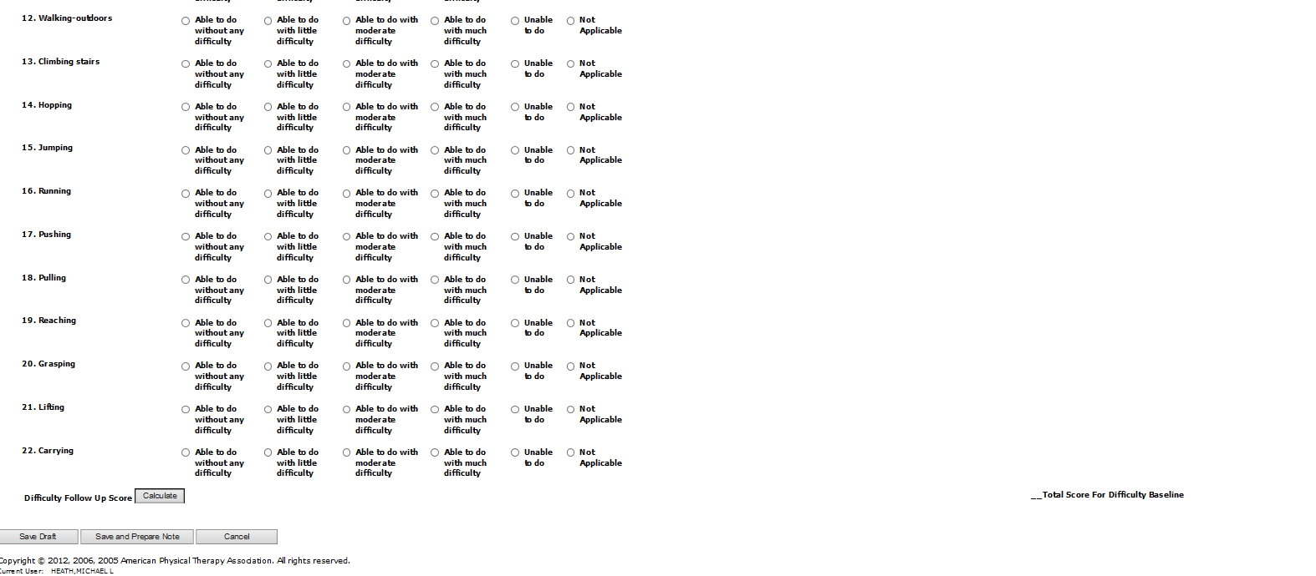

Figure 58 -OPTIMAL 1.1 Follow Up Screen (Part 2)

### Quebec User Evaluation of Satisfaction with Assistive Technology (QUEST)

The Quebec User Evaluation of Satisfaction with Assistive Technology (QUEST) is an outcomes assessment tool designed to measure satisfaction with assistive technology in a structured and standardized way.

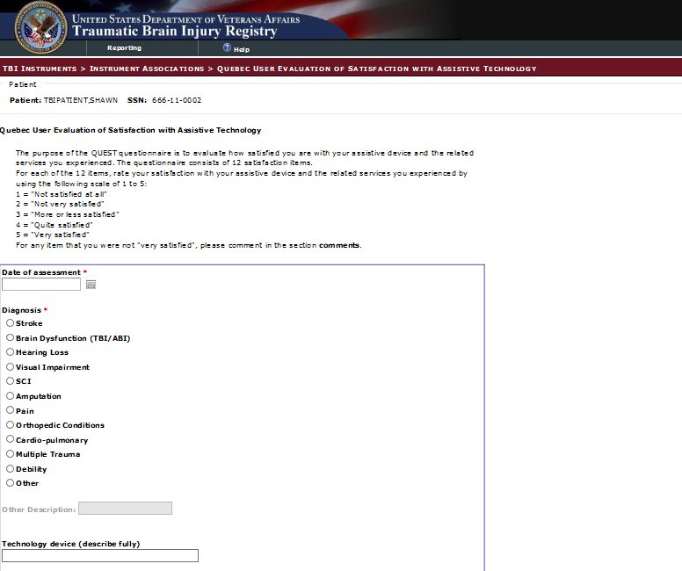

Figure 59 – Quebec User Evaluation of Satisfaction with Assistive Technology (QUEST)

### VA Low Visual Functioning (LA LV VFQ 20) Survey

The 20-item Veterans Affairs Low Vision Visual Functioning Questionnaire (VA LV VFQ) approximates the measure of persons' visual ability that would be calculated with Rasch analysis and to provide a short form version of the questionnaire for clinical practice and outcomes research.

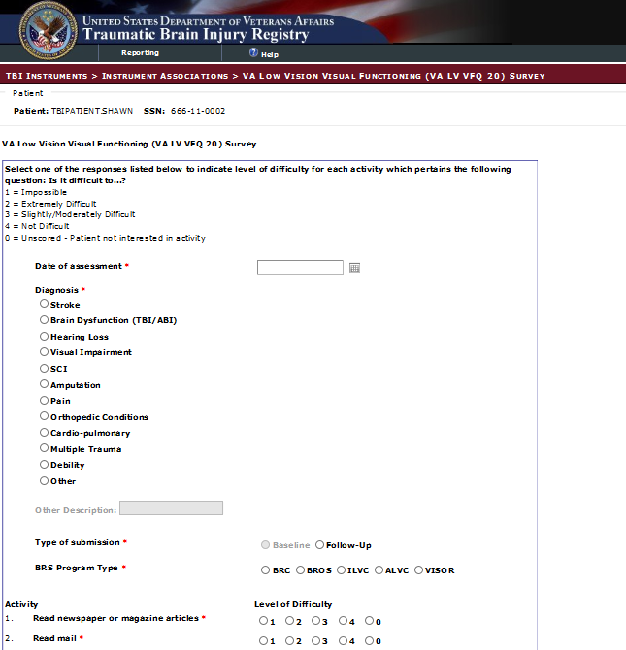

Figure 60 – VA Low Visual Functioning (LA LV VFQ 20) Survey

### Neurobehavioral Symptom Inventory (NSI)

The VA uses the Neurobehavioral Symptom Inventory (NSI) to measure postconcussive symptoms in its comprehensive traumatic brain

injury (TBI) evaluation.

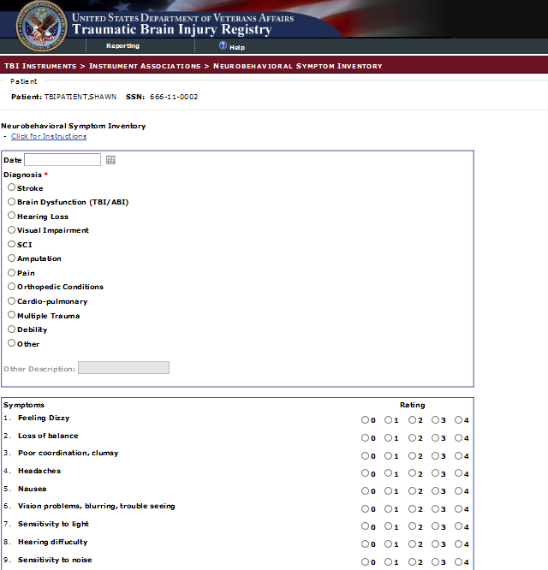

Figure 61 - Neurobehavioral Symptom Inventory (NSI)

### PROMIS - Pain Interference- Short Form 6a

The PROMIS Pain Interference instrument is used to measure the self-reported consequences of pain on relevant apects of a person’s life. This can include the degree to which pain hampers social, cognitive, emotional, physical, and recreational activities. This instrument includes the diagnosis and rehabilitation therapy provided to the individual.

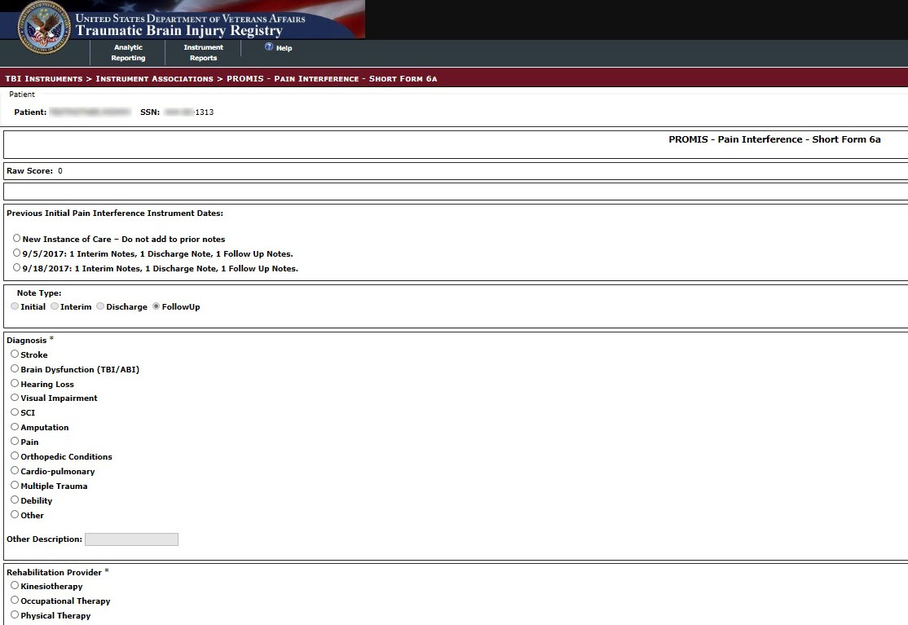

Figure 62 - PROMIS - Pain Interference - Short Form 6a (Part 1)

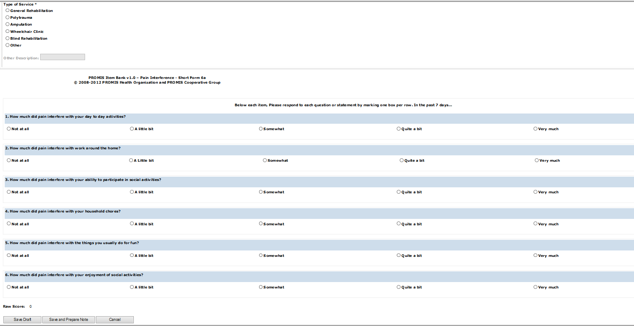

Figure 63 - PROMIS - Pain Interference - Short Form 6a (Part 2)

### PROMIS – Upper Extremity - Short Form 7a

The PROMIS Upper Extremity instrument focuses on activities that require use of the upper extremity including shoulder, arm, and hand activities. This instrument includes the diagnosis and rehabilitation therapy provided to the individual.

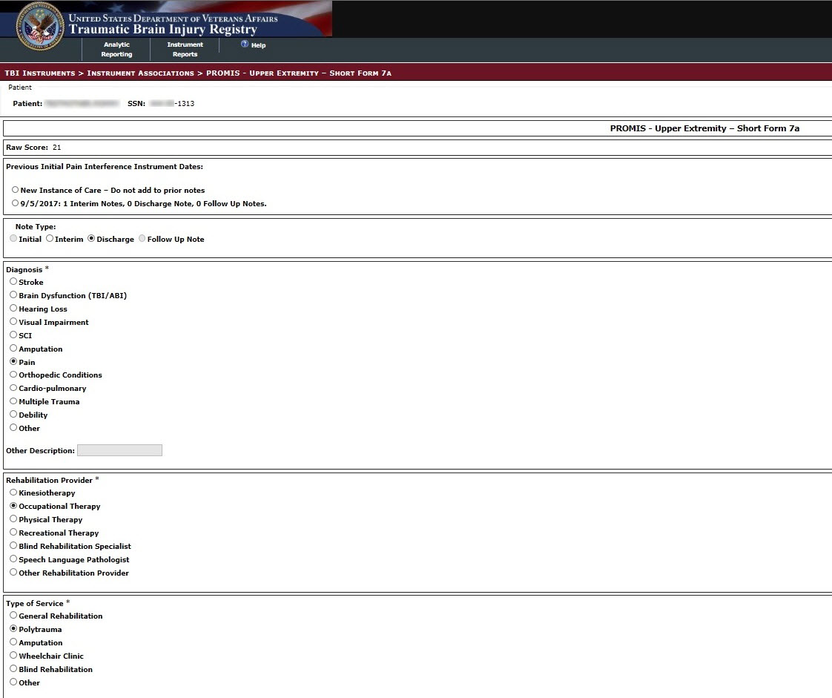

Figure 64 - PROMIS - Upper Extremity - Short Form 7a (Part 1)

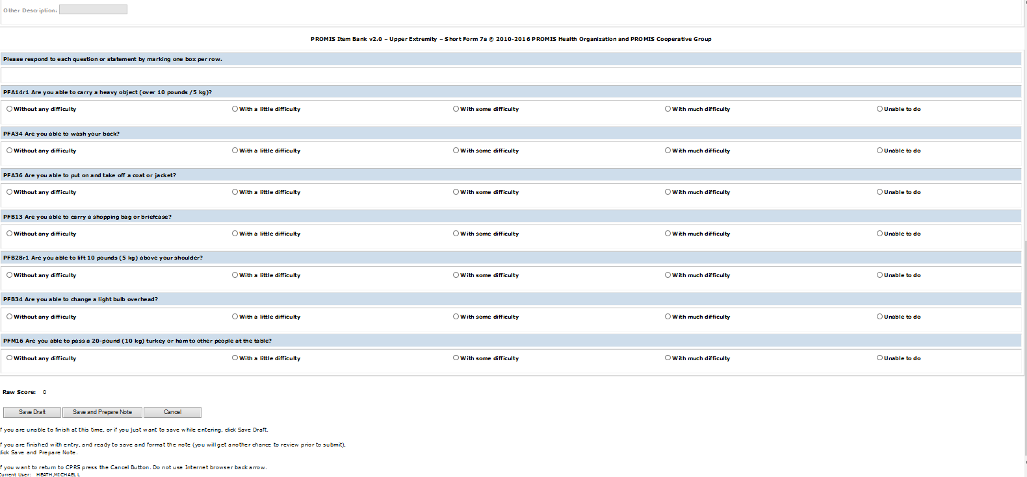

Figure 65 - PROMIS - Upper Extremity - Short Form 7a (Part 2)

### PROMIS – Physical Function with Mobility Aid

The PROMIS Upper Extremity instrument is used to measure the self-reported physical function of individuals with lower extremity issues that require the use mobility aids such as wheelchairs.. This instrument includes the diagnosis and rehabilitation therapy provided to the individual.

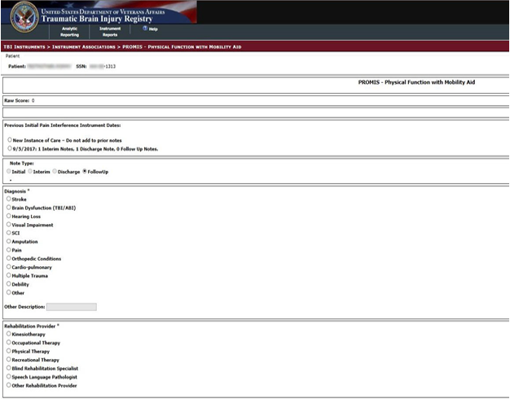

Figure 66 - PROMIS – Physical Function with Mobility Aid

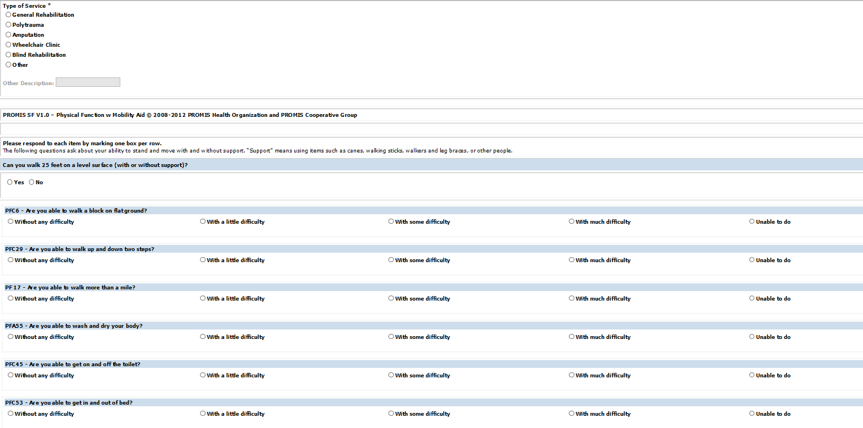

Figure 67 - PROMIS – Physical Function with Mobility Aid (Part 2)

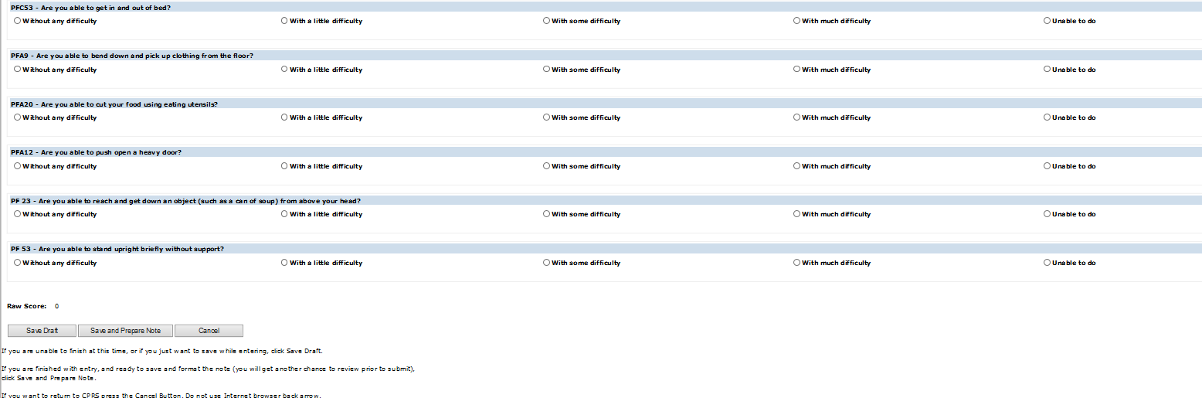

Figure 68 - PROMIS – Physical Function with Mobility Aid (Part 3)

### Patient Global Impression of Change (PGIC)

The Patient Global Impression of Change (PGIC) in pain intensity is measured on an pain intensity numerical rating scale (PI-NRS), where 0=no pain and 10=worst possible pain, and this chronic pain scale is related to global assessments of change.

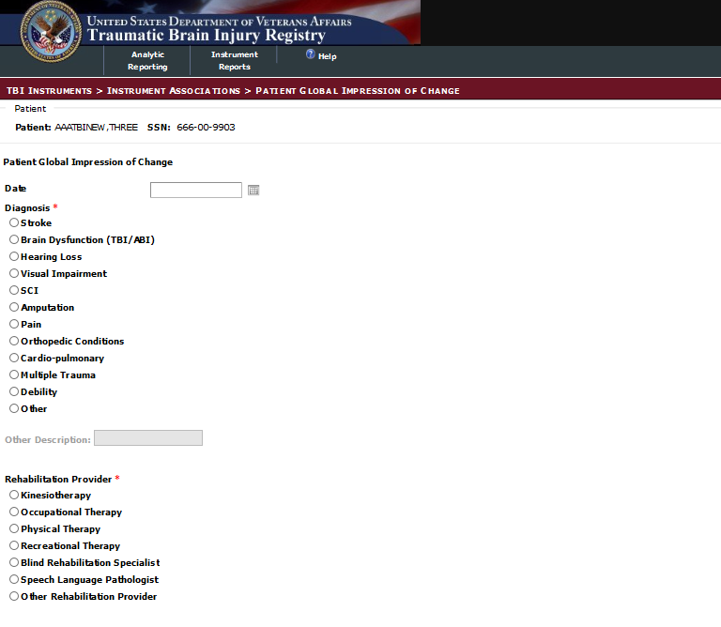

Figure 69 – Patient Global Impression of Change (PGIC) (Part 1)

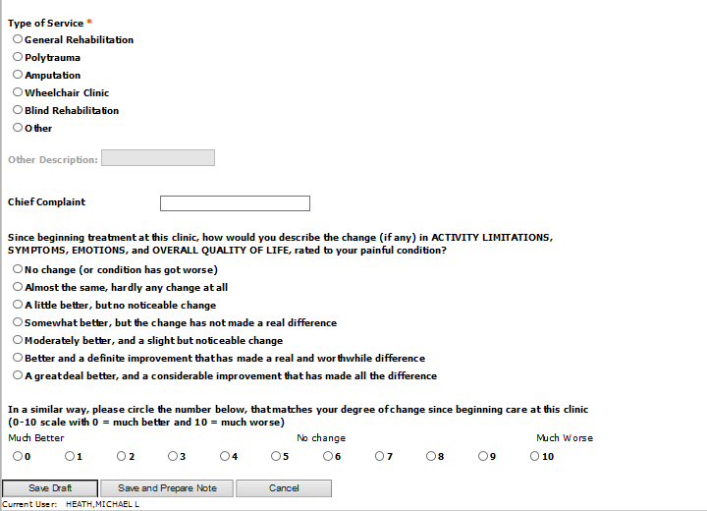

Figure 70 - Patient Global Impression of Change (Part 2)

### Satisfaction with Life Scale (SWLS)

The Satisfaction with Life Scale (SLWS) measures the global life satisfaction and the various components of subjective well-being. The SWLS is narrowly focused to assess global life satisfaction and does not tap related constructs such as positive affect or loneliness.

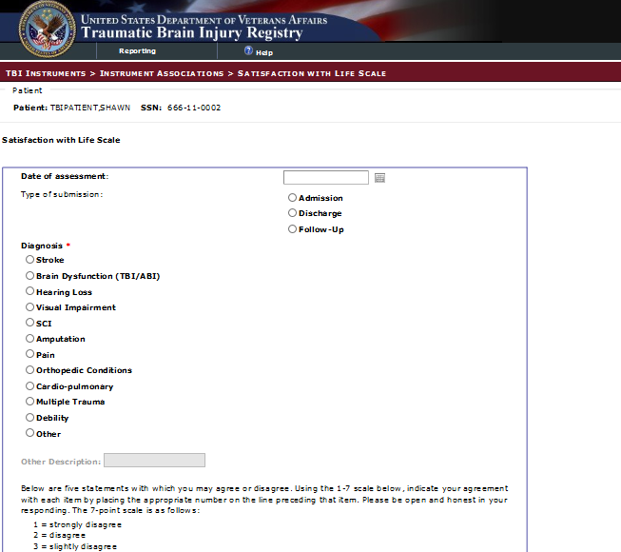

Figure 71 – Satisfaction with Life Scale (SWLS)

### Berg Balance Scale

The Berg Balance Scale is a 14-item objective measure designed to assess static balance and fall risk in adult populations.

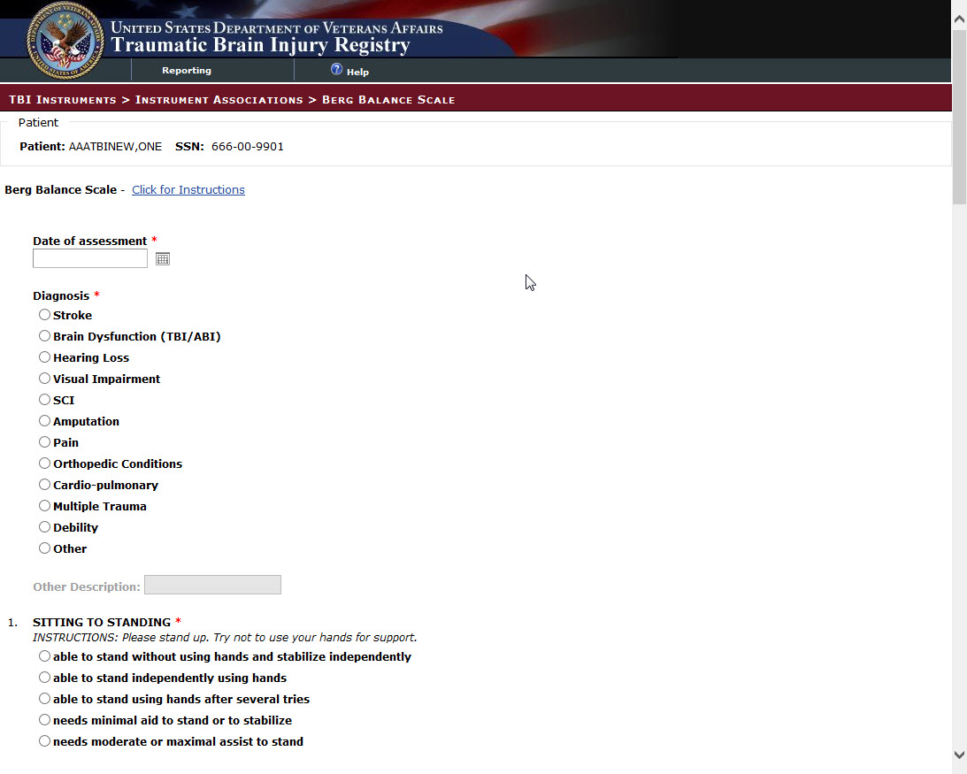

Figure 72 – Berg Balance Scale

### Disability Rating Scale (DRS)

The Disability Rating Scale (DRS) is commonly used by TBI rehabilitation facilities to assess a client's general level of functioning in terms of impairment, disability, and handicap. It is an assessment of current level of functioning among clients with traumatic brain injury (TBI) and often guides the establishment of realistic outcome goals for post-acute rehabilitation.

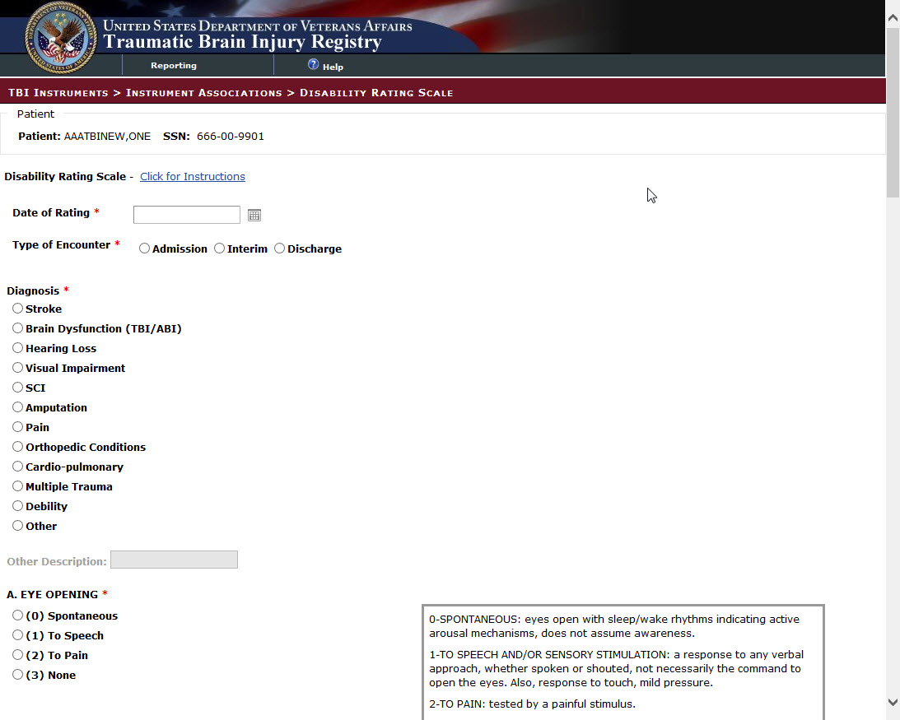

Figure 73 – Disability Rating Scale (DRS)

### Participation Assessment with Recombined Tools – Objectives (PART-O)

The Participation Assessment with Recombined Tools-Objective (PART-O, Whiteneck, Dijkers, Heinemann, et al., 2011) is an objective measure of participation, representing functioning at the societal level. The PART-O was developed to examine long-term outcomes and can also be used to evaluate the effectiveness of interventions to improve social/societal functioning. The z-scores can be used to provide the basis for an assessment of progress in post-acute rehabilitation, allowing for an assessment of intra-individual differences in change across domains as well as inter-individual comparisons with the normative groups.

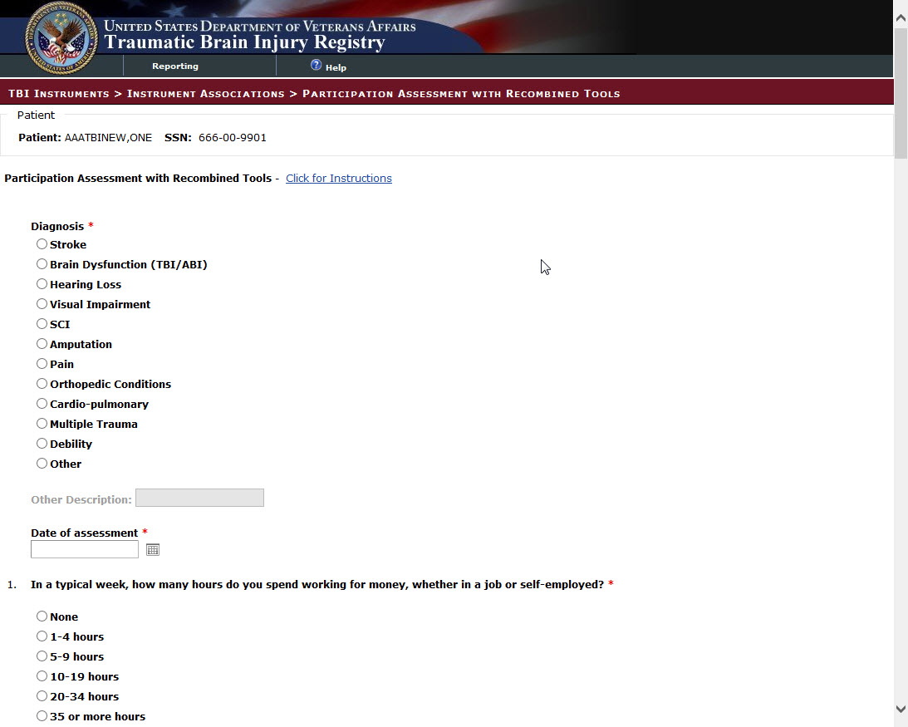

**Figure 74– Participation Assessment with Recombined Tools (PART-O) – 1 of 3**

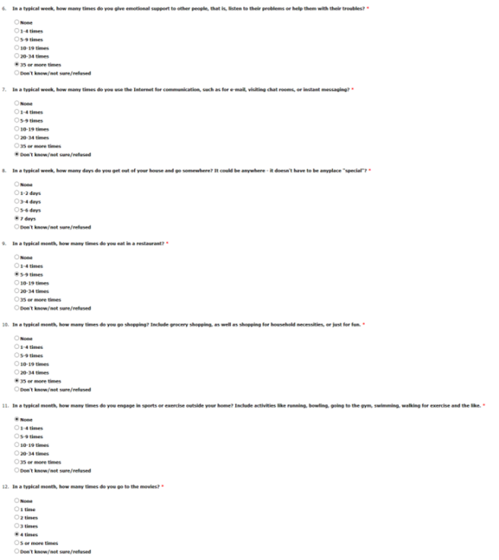

Figure 75 – Participation Assessment with Recombined Tools (PART-O) – 2 of 3

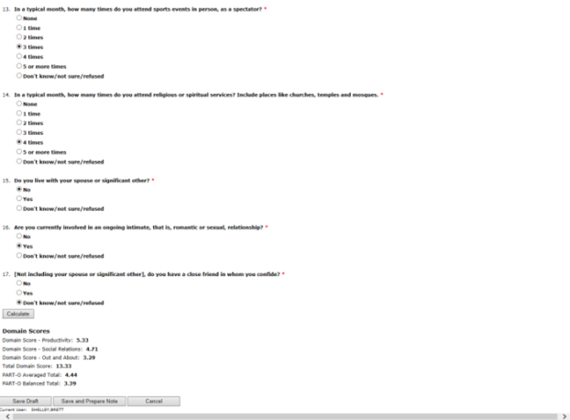

Figure 76 – Participation Assessment with Recombined Tools (PART-O) – 3 of 3

### JFK Coma Recovery Scale

The JFK Coma Recovery Scale was initially described by Giacino and colleagues in 1991. The scale was restructured by Giacino and Kalmar and republished in 2004 as the JFK Coma Recovery Scale-Revised (Giacino, Kalmar and Whyte, 2004). The purpose of the scale is to assist with differential diagnosis, prognostic assessment and treatment planning in patients with disorders of consciousness. The scale consists of 23 items that comprise six subscales addressing auditory, visual, motor, oromotor, communication and arousal functions. CRS-R subscales are comprised of hierarchically-arranged items associated with brain stem, subcortical and cortical processes. A recently-published review of behavioral assessment methods completed by European researchers recommended use of the CRS-R as a "new promising tool" for evaluation of consciousness after severe brain injury (Majerus, et al., 2005).

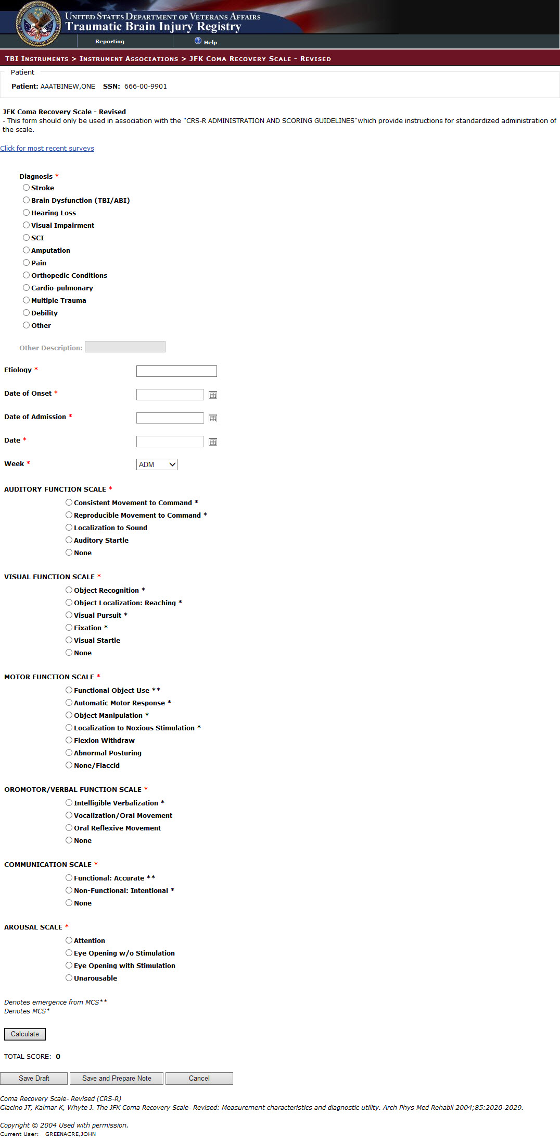

Figure 77 - JFK Coma Recovery Scale - Revised (CRS-R)

### Oswestry Disability

The Oswestry Disability Index (also known as the Oswestry Low Back Pain Disability Questionnaire) is an extremely important tool that researchers and disability evaluators use to measure a patient's permanent functional disability. The test is considered the ‘gold standard’ of low back functional outcome tools.

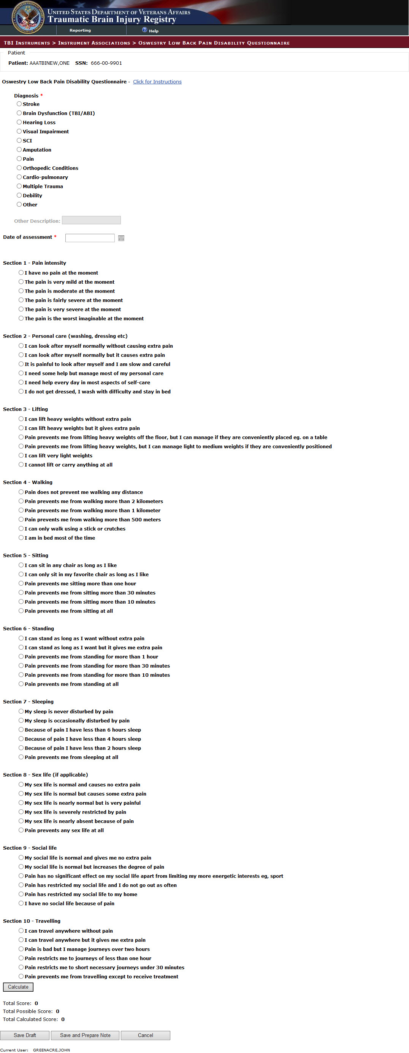

Figure 78 - Oswestry Low Back Pain Disability Questionnaire – 1 of 2

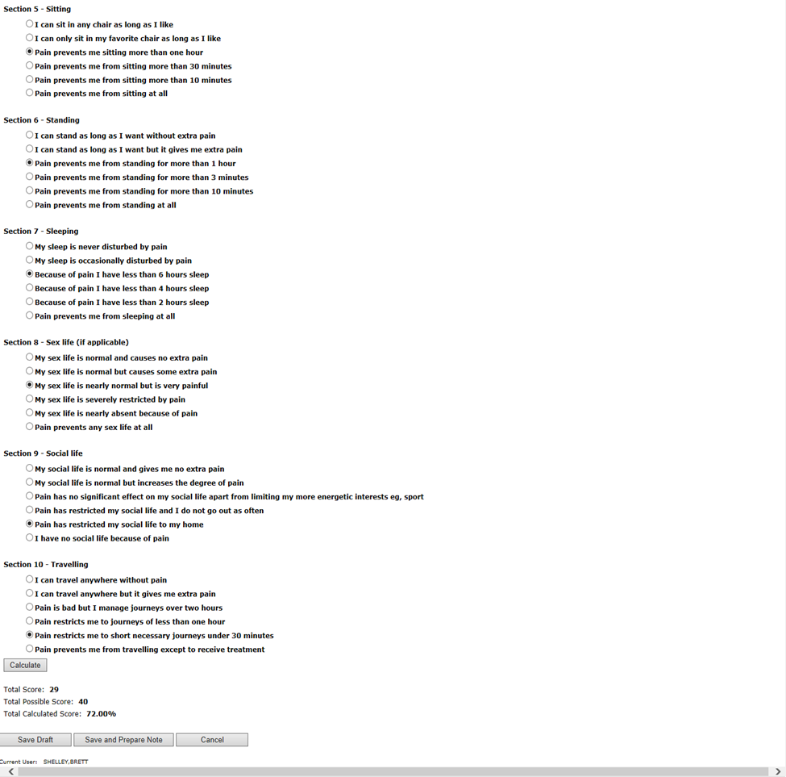

Figure 79 – Oswestry Low Back Pain Disability Questionnaire – 2 of 2

### Timed Up and Go

Timed Up and Go Dual Task; Timed Up and Go (Cognitive); Timed Up and Go (Motor); Timed Up and Go (Manual). A dual-task dynamic measure for identifying individuals who are at risk for falls.

### Generalized Anxiety Disorder Scale (GAD-7)

The 7-item Generalized Anxiety Disorder Scale (GAD-7) is a practical self-report anxiety questionnaire that has been proved valid as a measure of anxiety in the general population. Though designed primarily as a screening and severity measure for generalized anxiety disorder, the GAD-7 also has moderately good operating characteristics for three other common anxiety disorders – panic disorder, social anxiety disorder, and post-traumatic stress disorder.

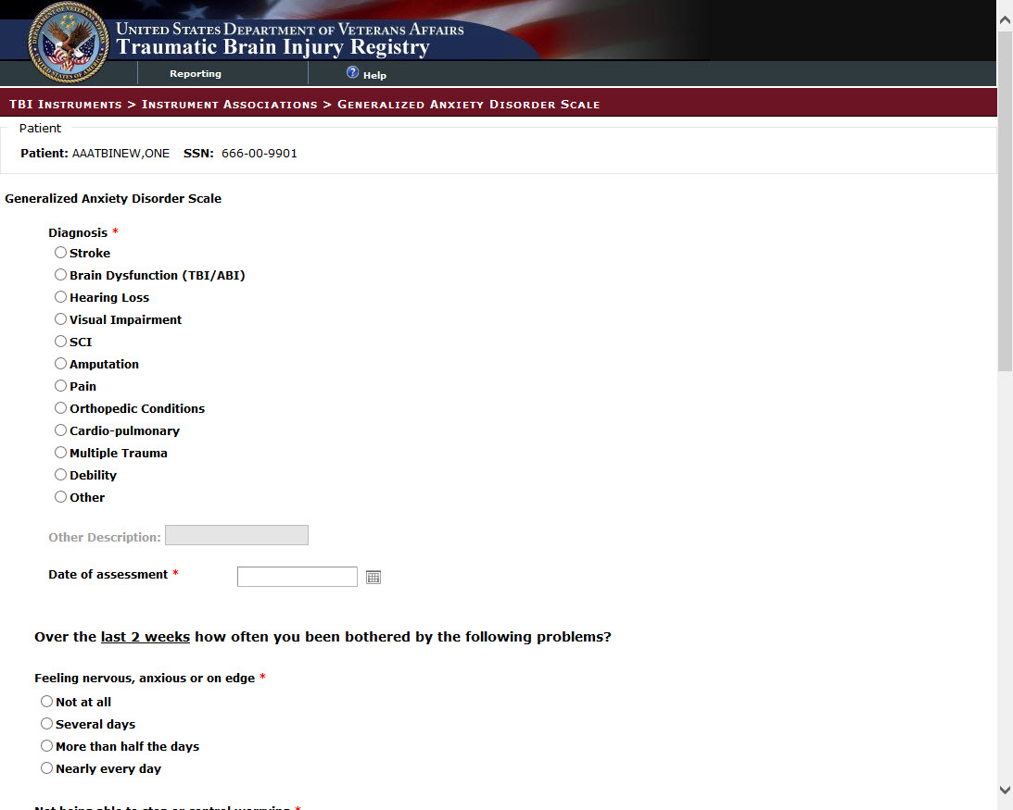

Figure 80 - Generalized Anxiety Disorder Scale (GAD-7)

### Post Traumatic Stress Disorder (PTSD) Checklist – Civilian Version (PCL-C)

The PCL-5 is a 20-item self-report measure that assesses the 20 DSM-5 symptoms of PTSD. The PCL-5 has a variety of purposes, including:

* Monitoring symptom change during and after treatment
* Screening individuals for PTSD
* Making a provisional PTSD diagnosis
* The gold standard for diagnosing PTSD is a structured clinical interview such as the Clinician-Administered PTSD Scale (CAPS-5). When necessary, the PCL-5 can be scored to provide a provisional PTSD diagnosis.
* The PCL-5 can be administered in one of three formats:
  + without Criterion A (brief instructions and items only), which is appropriate when trauma exposure is measured by some other method
  + with a brief Criterion A assessment
  + with the revised Life Events Checklist for DSM-5 (LEC-5) and extended Criterion A assessment

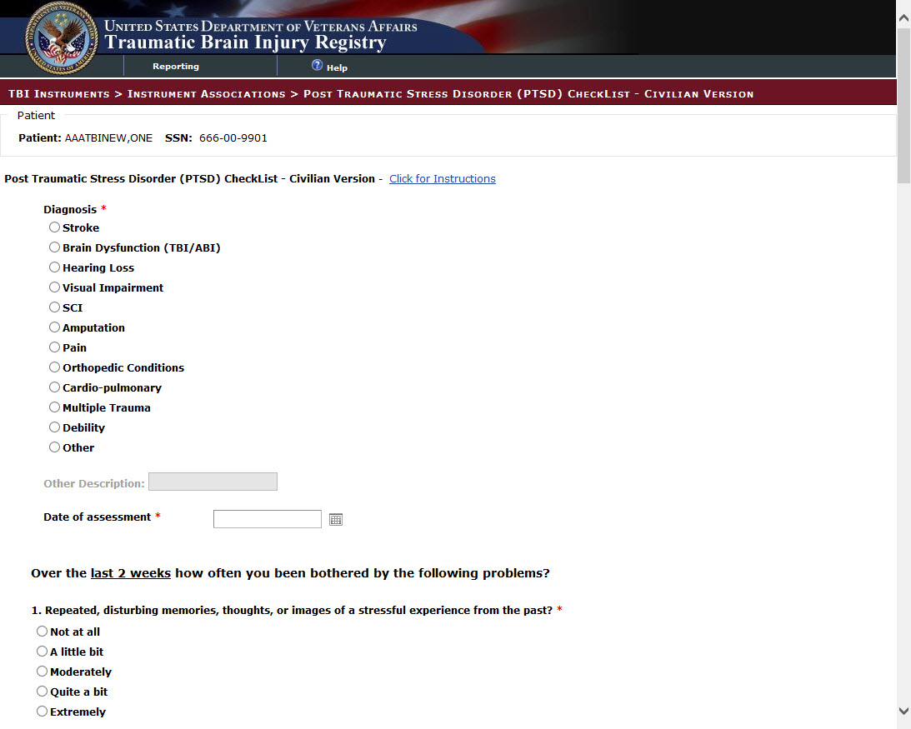

Figure 81 – Post Traumatic Stress Disorder (PTSD) Checklist – Civilian Version (PCL-C) – 1 of 3

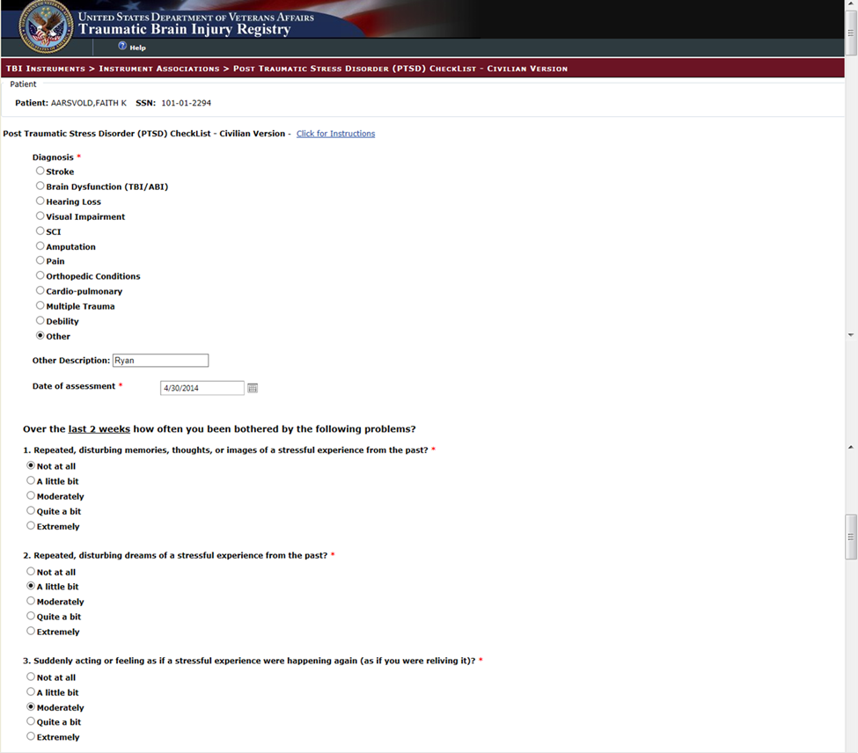

Figure 82 – Post Traumatic Stress Disorder (PTSD) Checklist – Civilian Version (PCL-C) – 2 of 3

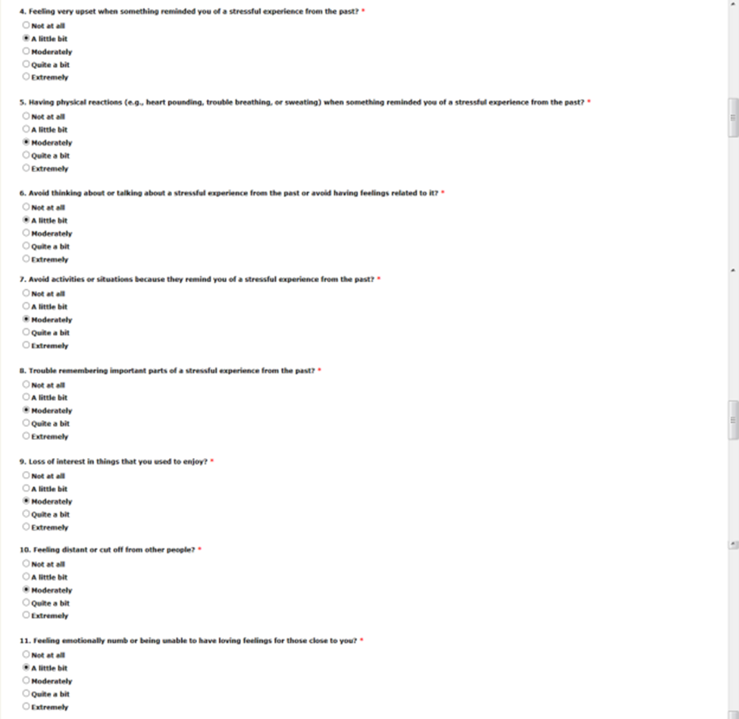

Figure 83 – Post Traumatic Stress Disorder (PTSD) Checklist – Civilian Version (PCL-C) – 3 of 3

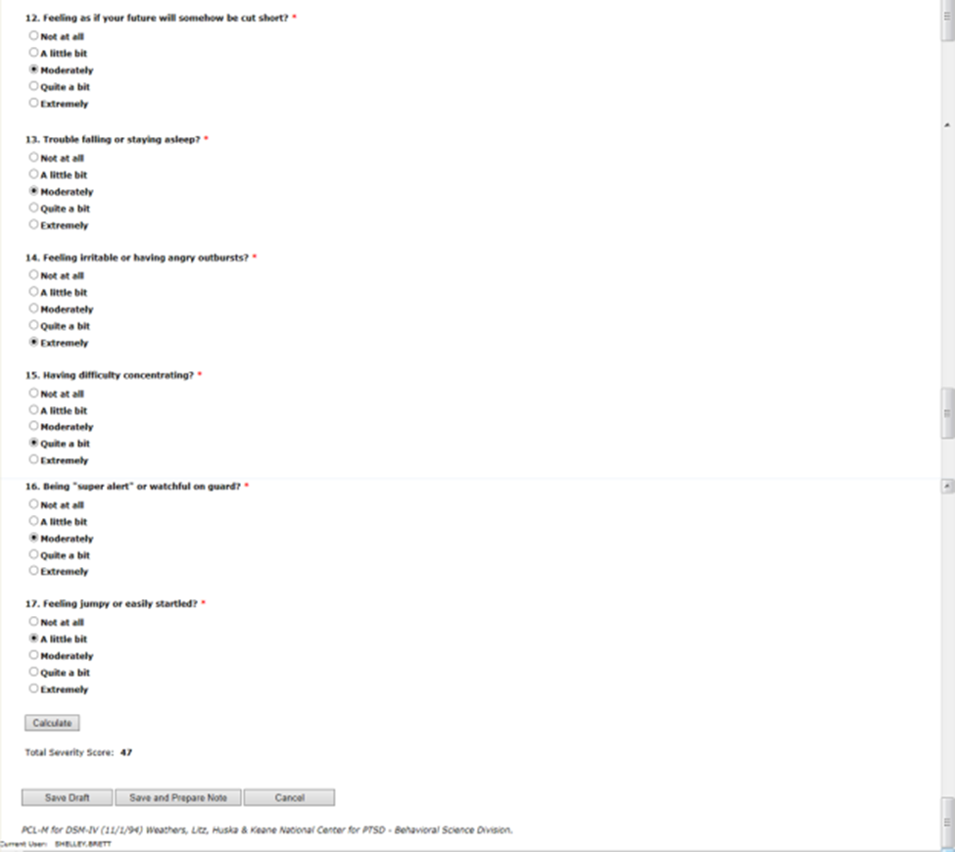

Figure 84 – Post Traumatic Stress Disorder (PTSD) Checklist – Civilian Version (PCL-C) – 3 of 3

### Patient Health Questionnaire – 9 (PHQ-9)

The Patient Health Questionnaire (PHQ) is a self-administered version of the PRIME-MD diagnostic instrument for common mental disorders. The PHQ-9 is the depression module, which scores each of the 9 DSM-IV criteria as “0” (not at all) to “3” (nearly every day). The PHQ-9 is a nine item depression scale based directly on the diagnostic criteria for major depressive disorder in the Diagnostic and Statistical Manual Fourth Edition (DSM-IV). The PHQ-9 is a powerful tool for assisting primary care clinicians in diagnosing depression as well as selecting and monitoring treatment.

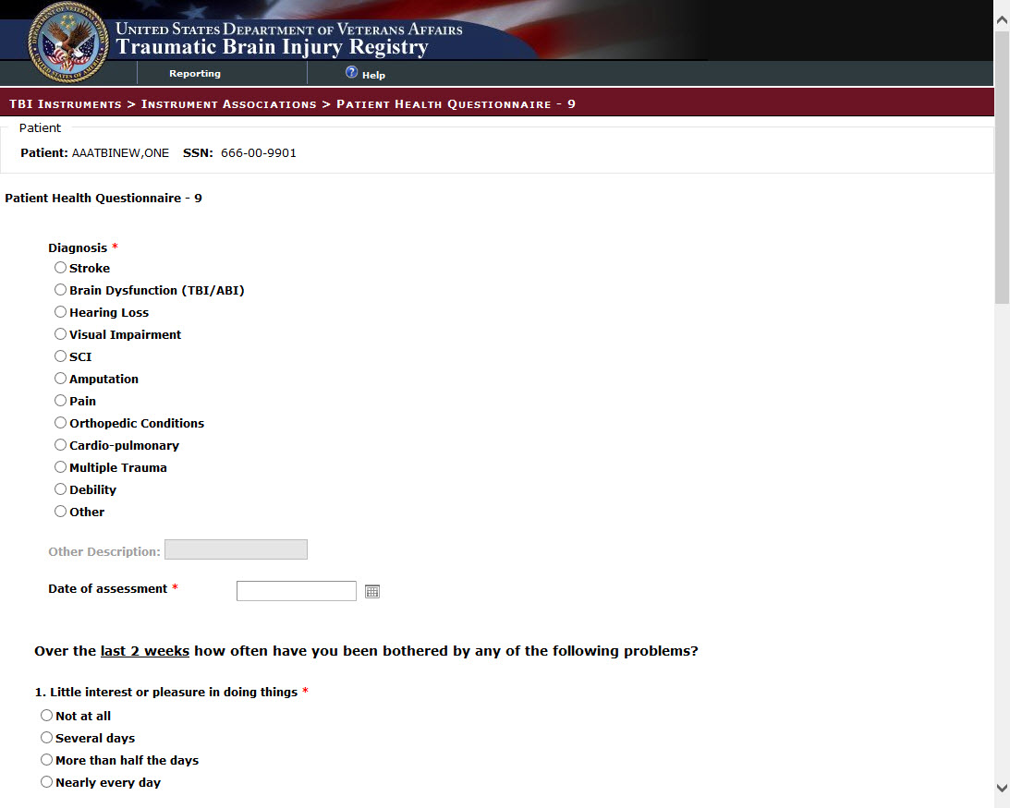

Figure 85 – Patient Health Questionnaire – 9 (PHQ-9) – 1 of 2

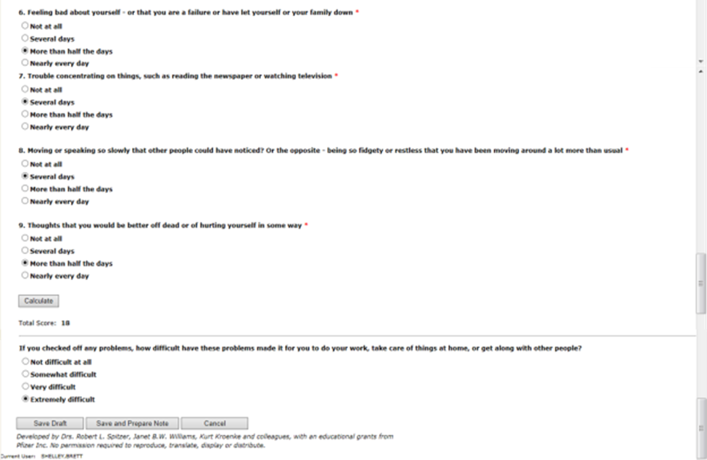

Figure 86 – Patient Health Questionnaire - 9 (PHQ-9) - 2 of 2

### Supervision Rating Scale (SRS)

The Supervision Rating (SRS) measures the level of supervision that a patient/subject receives from caregivers. The SRS rates level of supervision on a 13-point ordinal scale that can optionally be grouped into five ranked categories (Independent, Overnight Supervision, Part-Time Supervision, Full-Time Indirect Supervision, and Full-Time Direct Supervision). The SRS was designed to be rated by a clinician based on interviews with the subject and an informant who has observed at first hand the level of supervision received by the subject. Scoring is a one-step procedure in which the clinician assigns the rating that is closest to the subject's level. Ratings are based on the level of supervision received, not on how much supervision a subject is judged or predicted to need.

### Insomnia Severity Index (ISI)

Seven item questionnaire that is designed to assess the nature, severity, and impact of insomnia and monitor treatment response in adults. It measures severity of sleep onset, sleep maintenance and early morning wakening problems, sleep dissatisfaction, interference of sleep difficulties with daytime functioning, noticeability of sleep problems by others, and distress caused by the sleep difficulties.

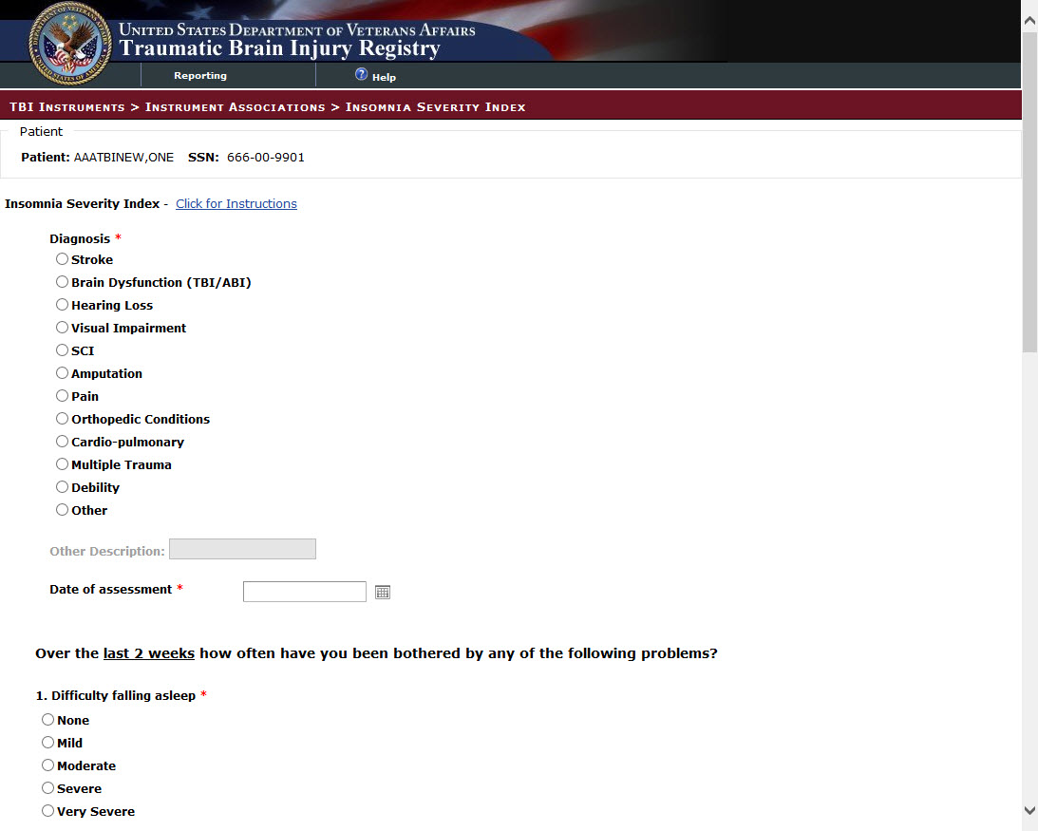

Figure 87 – Insomnia Severity Index (ISI) – 1 of 2

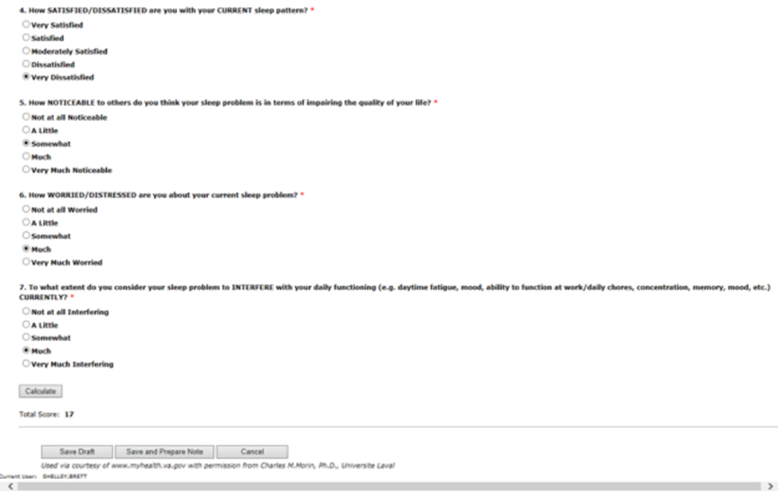

Figure 88 – Insomnia Severity Index (ISI) - 2 of 2

### Pain Outcomes Questionnaire VA Long Form – Intake

The development of effective pain treatment strategies requires the availability of precise and practical measures of treatment outcomes. The Pain Outcomes Questionnaire (POQ) is a multidimensional treatment outcomes measure consisting of 20 questions that assess specific aspects of pain syndromes. The POQ also provides six functional subcategories which may be of interest to clinicians: Pain, Mobility, Self-Care, Vitality (Energy), Negative Affect (Mood), and Fear of Re-injury. The POQ is an outcomes package consisting of intake, post-treatment, and follow-up questionnaires that was developed to assess several key domains of pain treatment outcomes. The POQ contains six core subscales that assess pain intensity, pain-interference in an activities of daily living (ADLs) and mobility, negative affect, activity diminishment, and pain-related fear.

**NOTE:** POQ is administered at intake, discharge, and follow up.

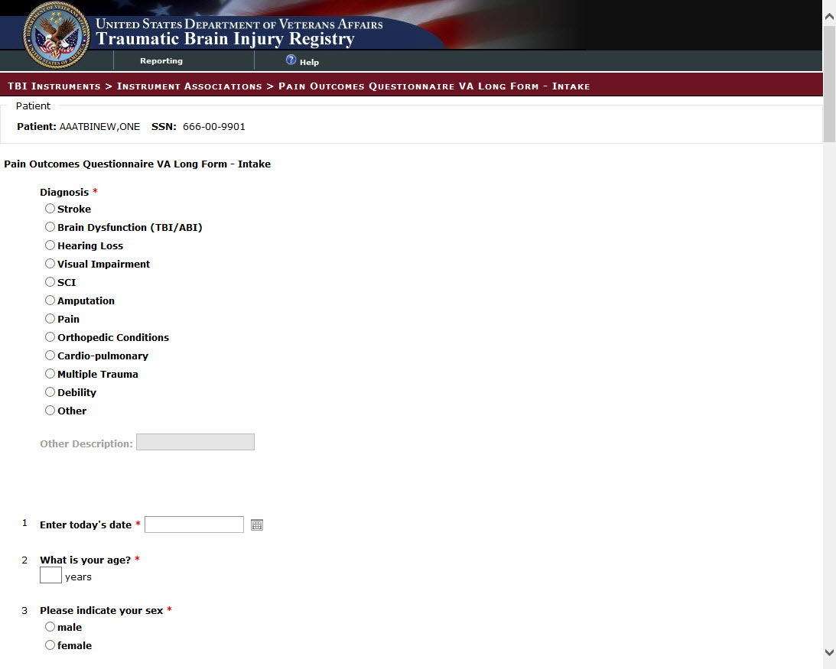

Figure 89 – Pain Outcomes Questionnaire VA Long Form – Intake – 1 of 3

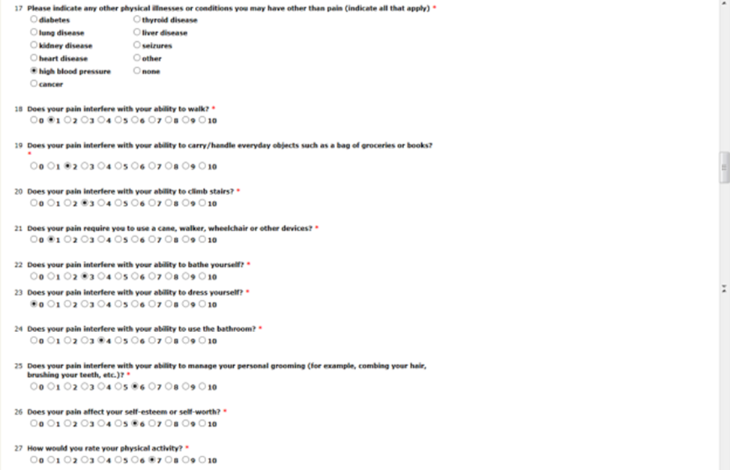

Figure 90 – Pain Outcomes Questionnaire VA Long Form – Intake – 2 of 3

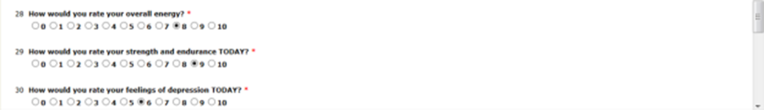

Figure 91 – Pain Outcomes Questionnaire VA Long Form – Intake – 3 of 3

### Pain Outcomes Questionnaire VA Long Form – Discharge

Refer to POQ Intake description above.

### Pain Outcomes Questionnaire VA Long Form – Follow-Up

Refer to POQ Intake description above.

### World Health Organization - Disability Assessment Schedule (WHODAS 2.0) Interview

The WHO Disability Assessment Schedule (WHODAS 2.0) is a unique practical instrument, based on the International Classification of Functioning, Disability and Health (ICF), that can be used to measure general health and disability levels, including mental and neurological disorders, both at the population level or in clinical practice, in a wide range of cultural settings.

* Generic assessment instrument for health and disability
* Used across all diseases, including mental, neurological and addictive disorders
* Short, simple and easy to administer (5 to 20 minutes)
* Applicable in both clinical and general population settings
* Produces standardized disability levels and profiles
* Applicable across cultures, in all adult populations
* Direct conceptual link to the International Classification of Functioning, Disability and Health (ICF)
* WHODAS 2.0 covers 6 domains:
* Cognition – understanding & communicating
* Mobility– moving & getting around
* Self-care– hygiene, dressing, eating & staying alone
* Getting along– interacting with other people
* Life activities– domestic responsibilities, leisure, work & school
* Participation– joining in community activities

NOTE: WHODAS 2.0 may be administered by interview, self, and proxy.

### World Health Organization - Disability Assessment Schedule (WHODAS 2.0) Self

Refer to WHODAS 2.0 Interview description above.

### World Health Organization - Disability Assessment Schedule (WHODAS 2.0) PROXY

Refer to WHODAS 2.0 Interview description above.

## Reporting

### Rehabilitation and Reintegration Care Plan Report

The Rehabilitation and Reintegration Care Plan Report allows users to generate a report containing the number of Rehabilitation and Reintegration Care Plan surveys that were created for their VHA/District/VISN/Facility based on a specific date range.

**NOTE:** Date for this report can be obtained for dates beginning from FY 2012 to the present date.

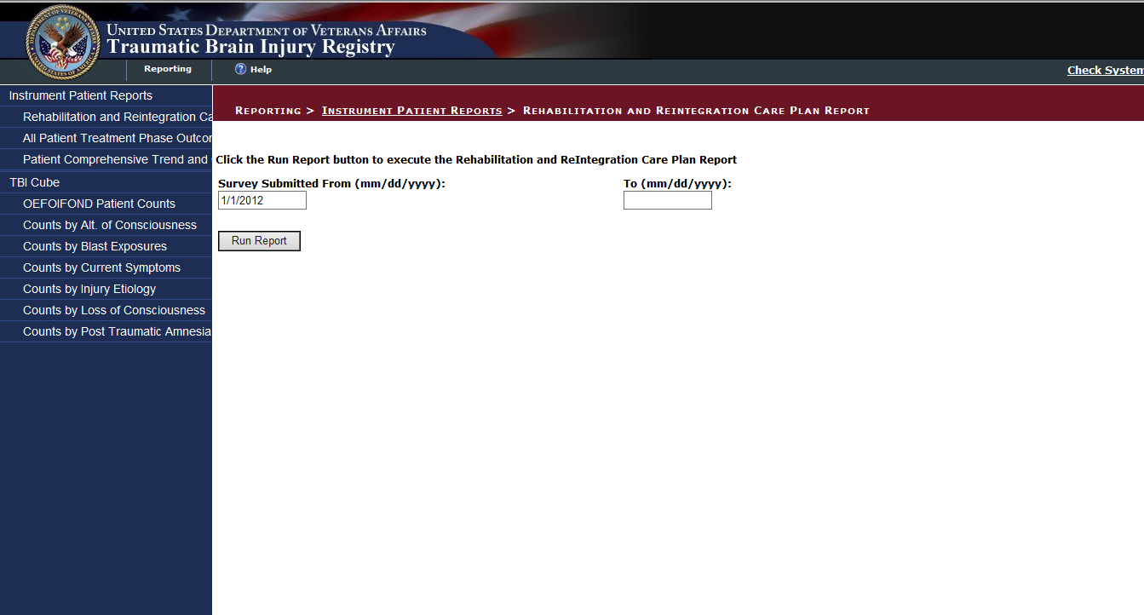

Figure 92 - Rehabilitation and Reintegration Care Plan (Initial Screen)

After specifying the date range, users click the **View Report** button. The report page refreshes to display a summary of the survey information based on their level of access.

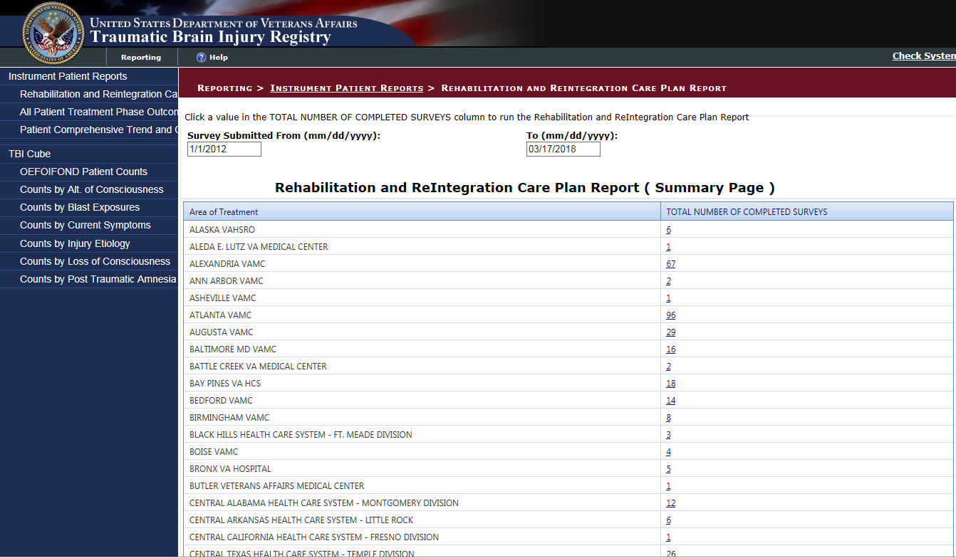

Figure 93 - Rehabilitation and Reintegration Care Plan Summary

To drill down to the next layer of information, click the number listed in the TOTAL NUMBER OF SURVEYS column. The page refreshes to display the survey information for that District/Facility/VISN.

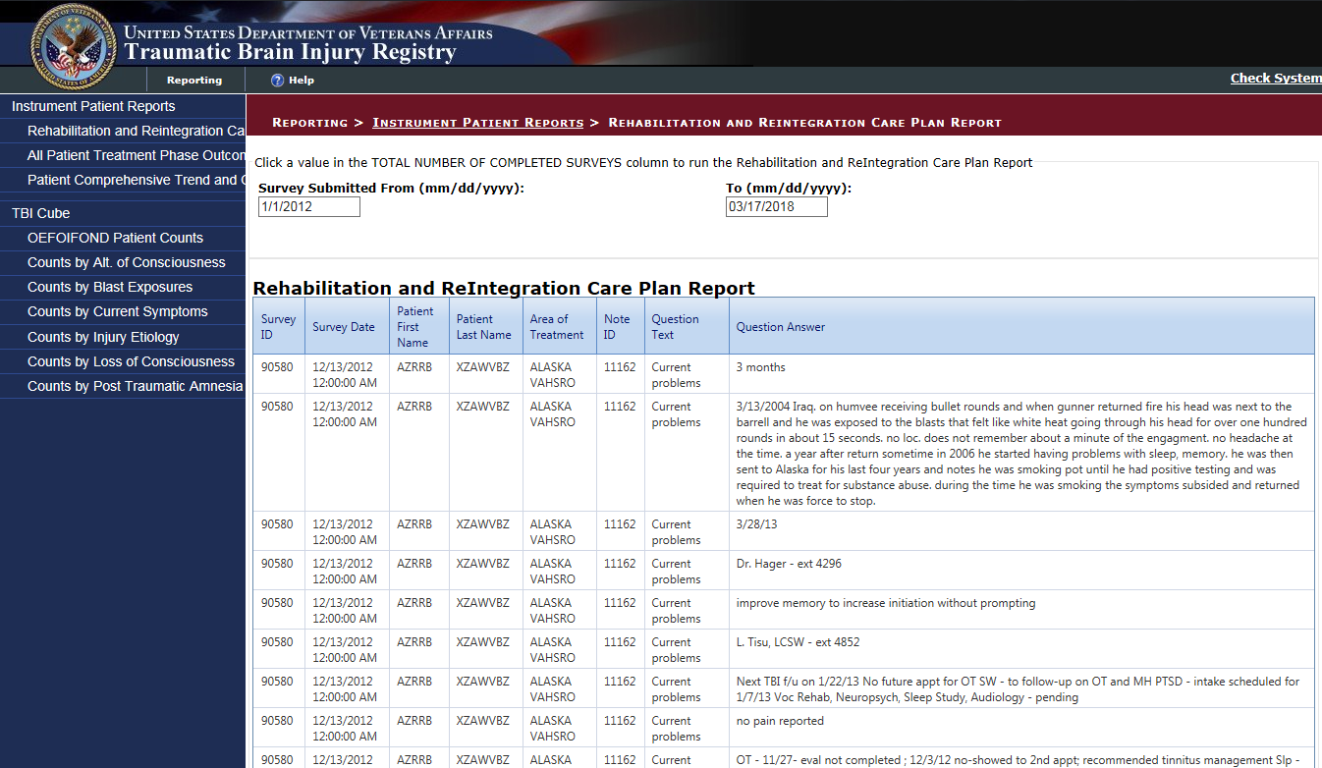

Figure 94 - Rehabilitation and Reintegration Care Plan List of Patients

### All Patient Treatment Phase Outcome Report

The All Patient Treatment Phase Outcome Report allows users to generate a report containing M2PI (t score) and all PROMIS forms (total scores).

Users can specify the following report filter criteria:

* Note Submission Date Range—Specify the date range for which you want to generate the report.  
    
  **NOTE:** Date for this report can be obtained for dates beginning from FY 2012 to the present date.
* Survey Type— Select the surveys for which you want to generate the report.The available options include: **Select All**, **MPAI-4 Participaton Index (M2PI)**, **PROMIS – Pain Interference Short – Form 6a**, **PROMIS – Physical Function with Mobility Aid**, and **PROMIS – Upper Extremity – Short Form 7a**
* Note Type— Select the Note types for which you want to generate the report.The available options include: **Select All**, **Initial**, **Interim**, **Discharge**, and **FollowUp**.
* Patient Facility—Select the facilities for which you want to generate the report.

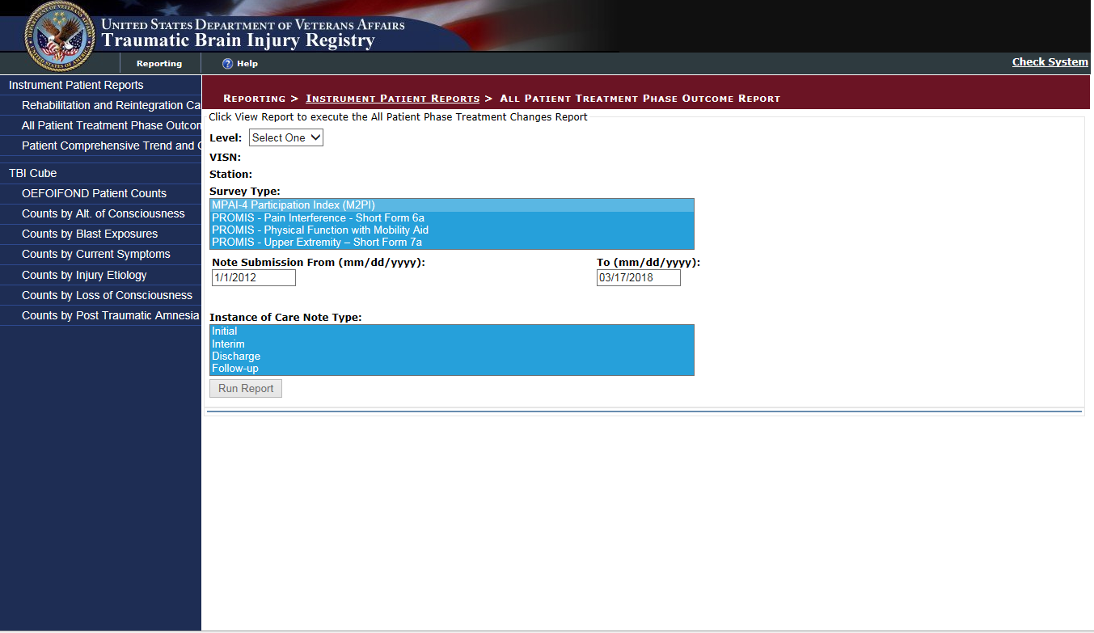

Figure 95 - Patient Treatment Phase Outcome Report (Initial Screen)

After specifying the report filter criteria, users click the **View Report** button. The report page refreshes to display the report results.

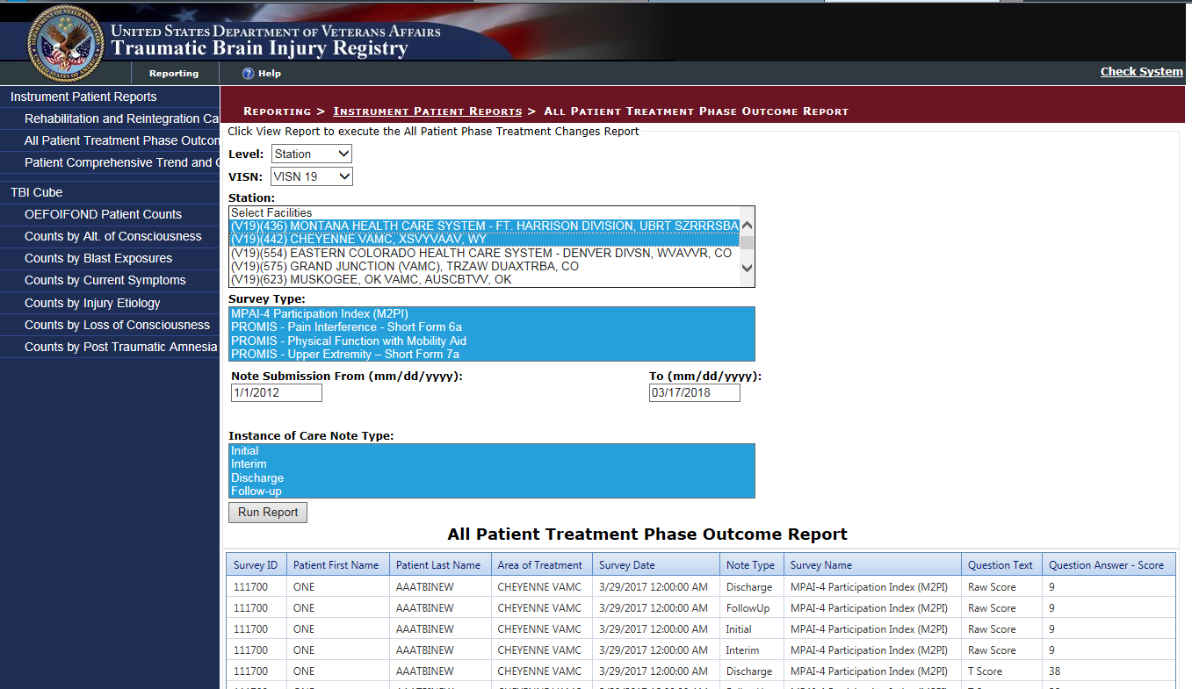

Figure 96 - Patient Treatment Phase Outcome Report Results

### Patient Comprehensive Trend and Outcomes Report

The Patient Comprehensive Trend and Outcomes Report allows users to generate a report that provides the average change in score related to M2PI (t score) and all PROMIS forms (total scores)., since the the last reported score based on the report filter options.

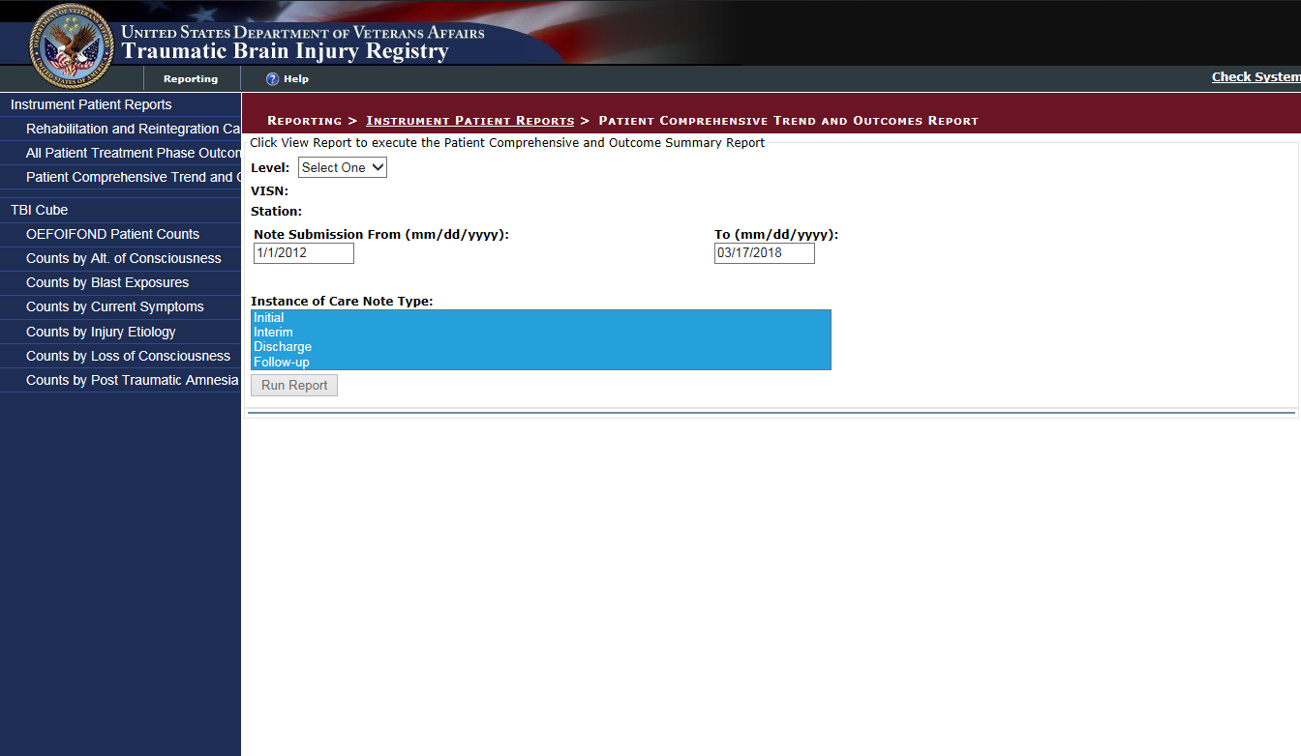

Figure 97 - Patient Comprehensive Trend and Outcomes Report (Initial Screen)

Users can specify the following report filter criteria:

* Note Submitted Date Range—Specify the date range for which you want to generate the report.  
    
  **NOTE:** Date for this report can be obtained for dates beginning from 2012 to the present date.
* Note Type— Select the Note types for which you want to generate the report.The available options include: **Select All**, **Initial**, **Interim**, **Discharge**, and **FollowUp**.
* Select Facility ID—Select the facilities for which you want to generate the report.

After specifying the report filter criteria, users click the **View Report** button. The report page refreshes to display the report results.

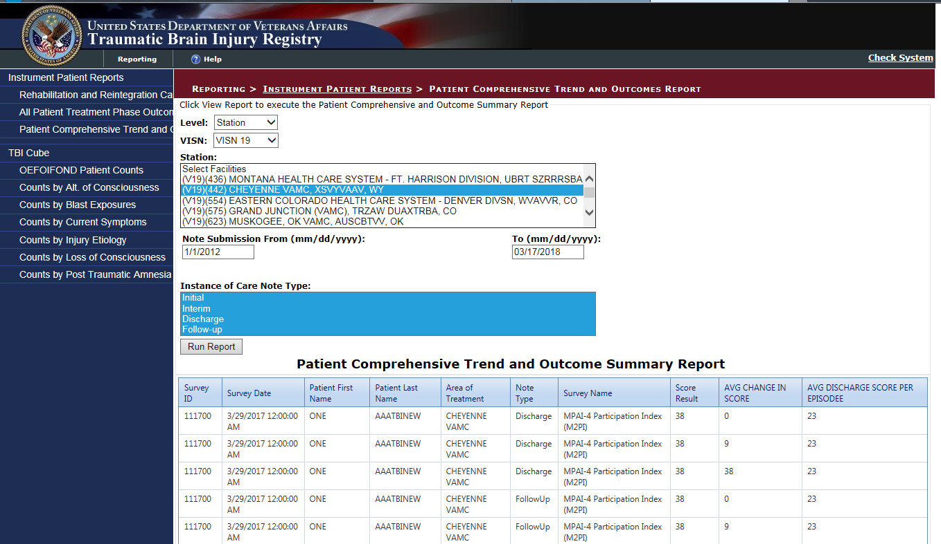

Figure 98 - Patient Comprehensive Trend and Outcome Summary Report Results

### Individual Instrument Reports

The questionnaire answers are summarized and displayed on the screen as shown below. Each report will maintain the same format, however, the questions contained in the report will be specific to each summary. The MAPI Summary is used in this example.

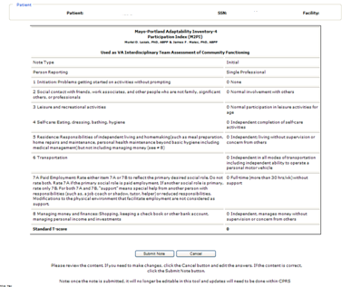

Figure 99 – Sample Report

If the user wants to make changes to the material, the user should click [Cancel] button and re-enter the answers. If the content is correct, the user clicks the [Submit Note] button.

Be aware that once the note is submitted, it is no longer editable within the TBI Instruments application and any updates will have to be made within CPRS.

The clinician must sign the note in CPRS.

### Analytics Reporting

Analytics reporting for TBI instruments is accessed by clicking the ‘Reporting’ link at the top of the page, clicking this link will take the user to the Traumatic Brain Injury Reporting Dashboard. From there the user will see categories listed on the first level and tabbed reports on the second.

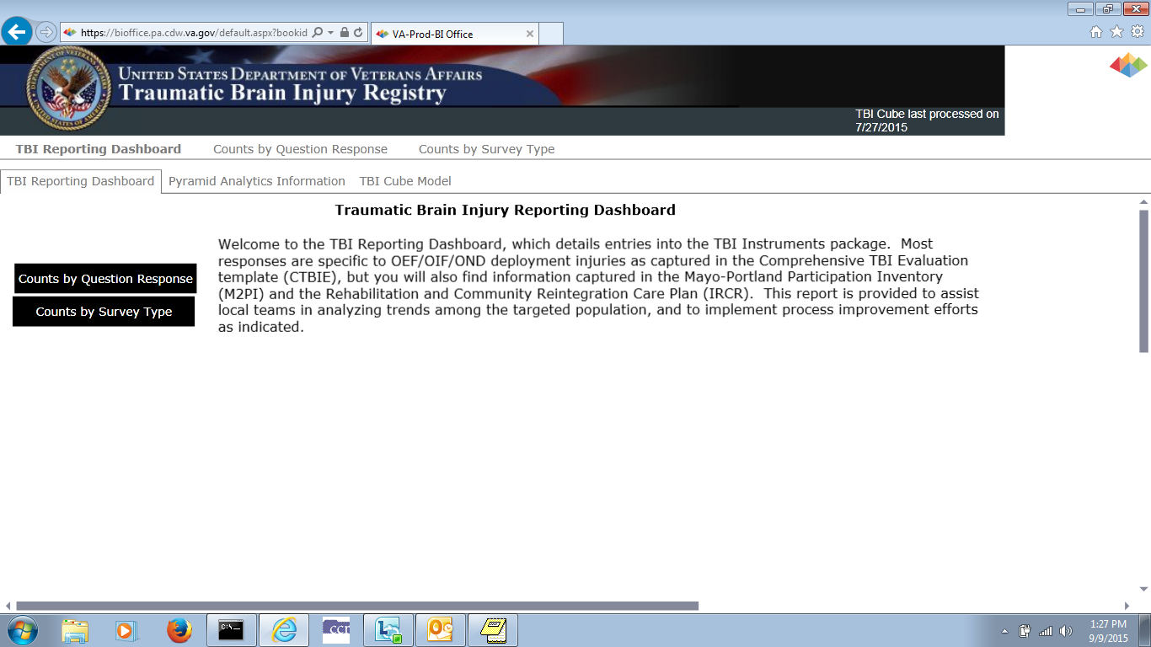

Figure 100 - TBI Reporting Dashboard

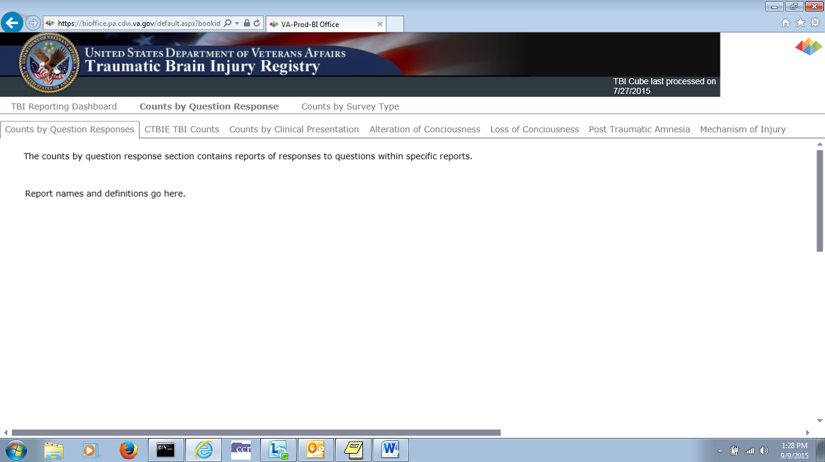

Figure 101 – Counts by Question Response Report Definitions

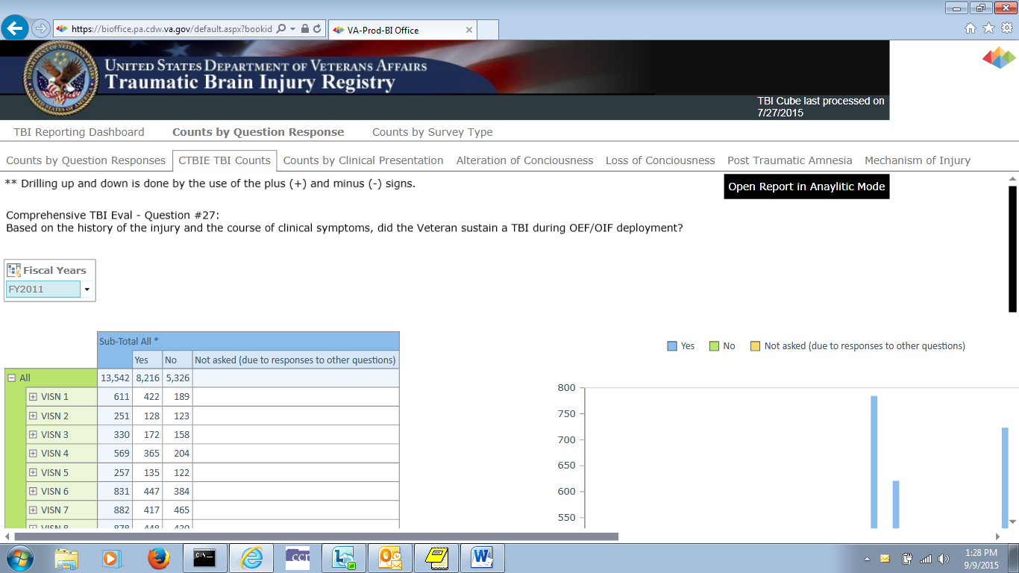

Figure 102 – Comprehensive TBI Exam Counts 1

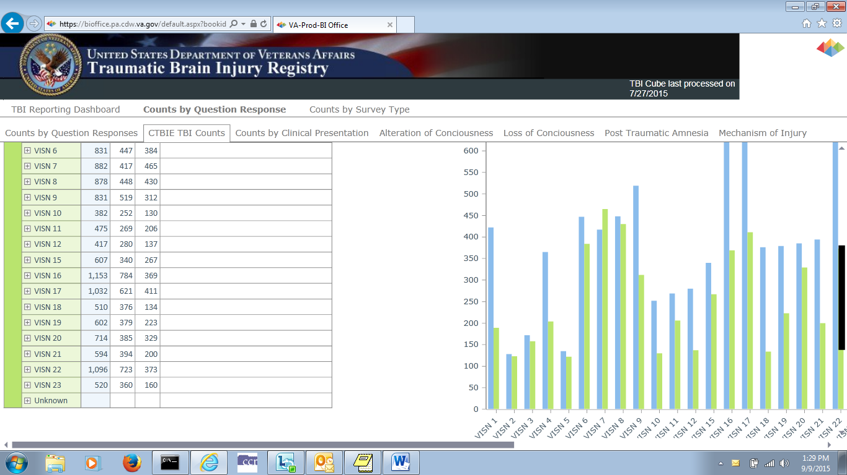

Figure 103 – Comprehensive TBI Exam Counts 2

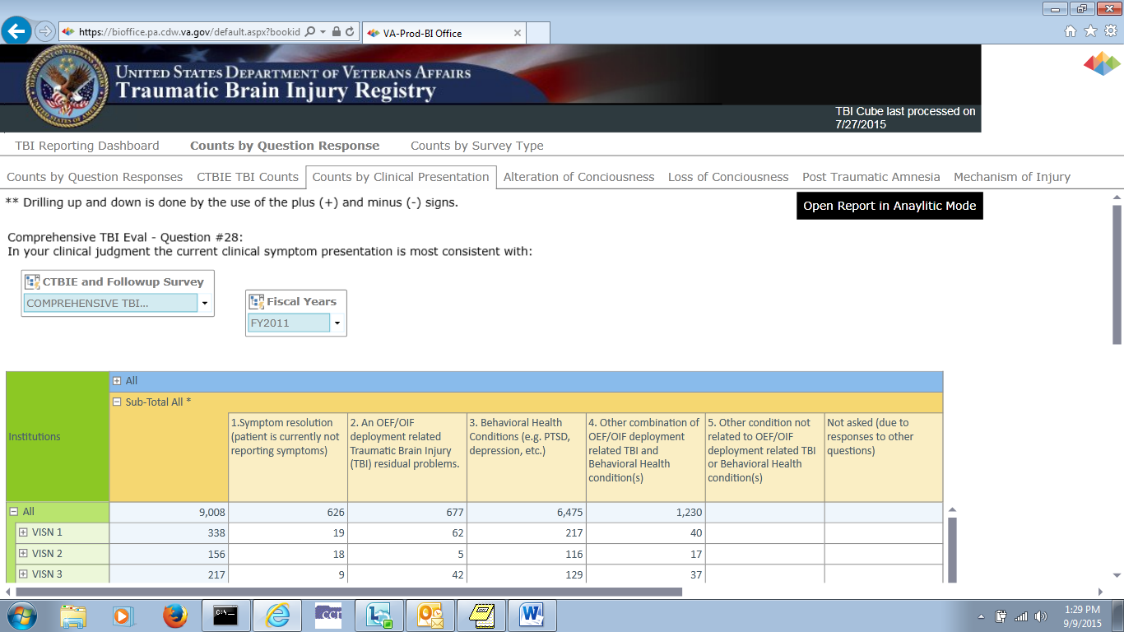

Figure 104 – Counts by Clinical Presentation

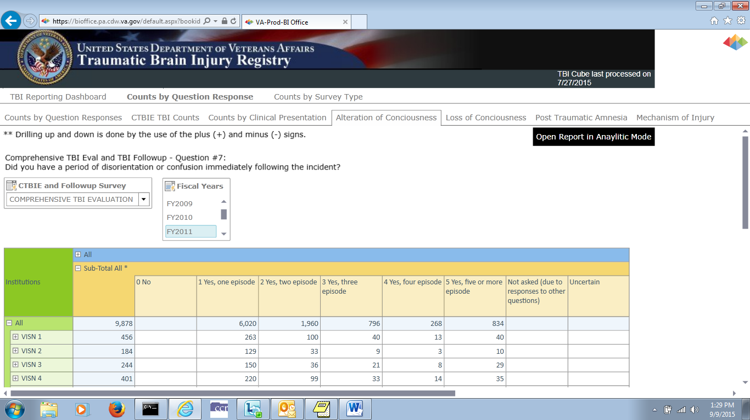

Figure 105 – Alteration of Conciousness Counts

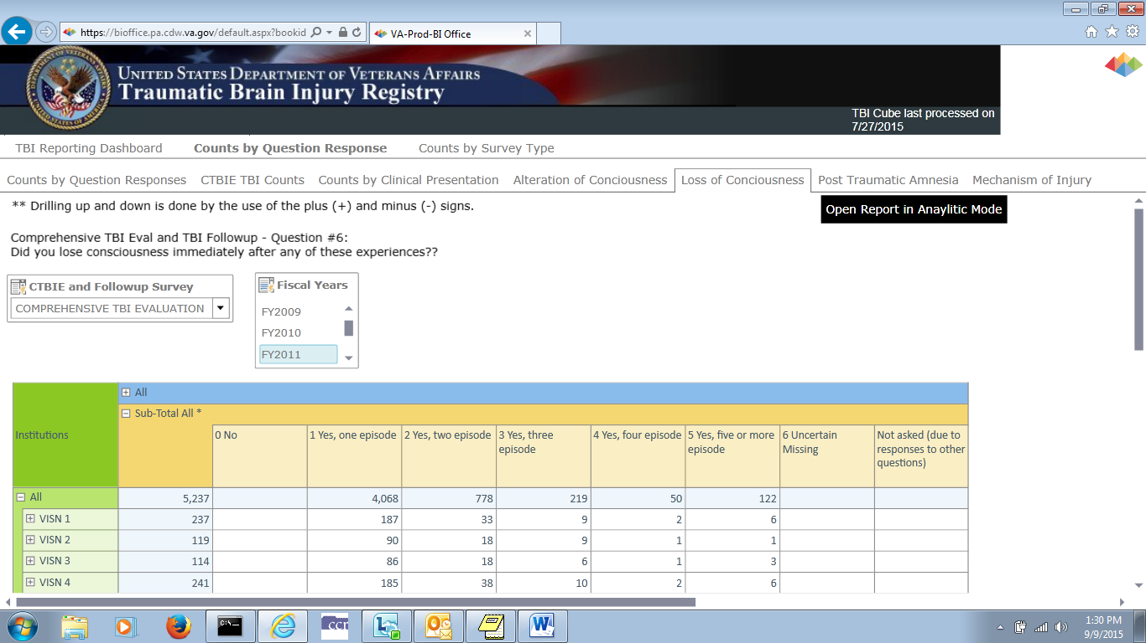

Figure 106 – Loss of Conciousness Counts

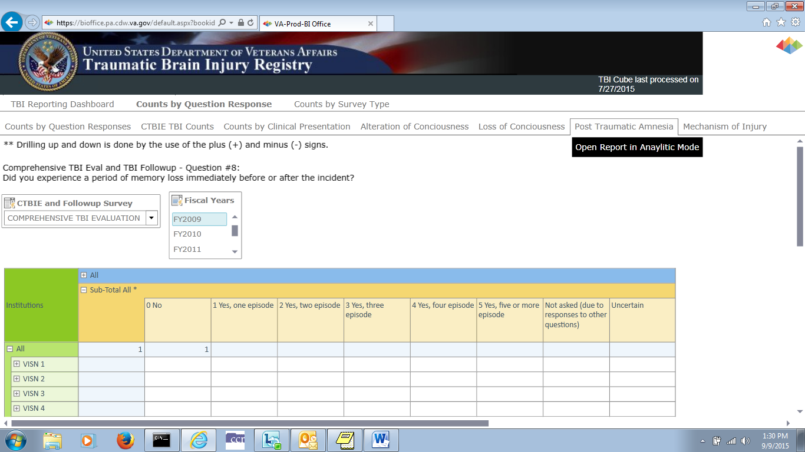

Figure 107 – Post Traumatic Amnesia Counts

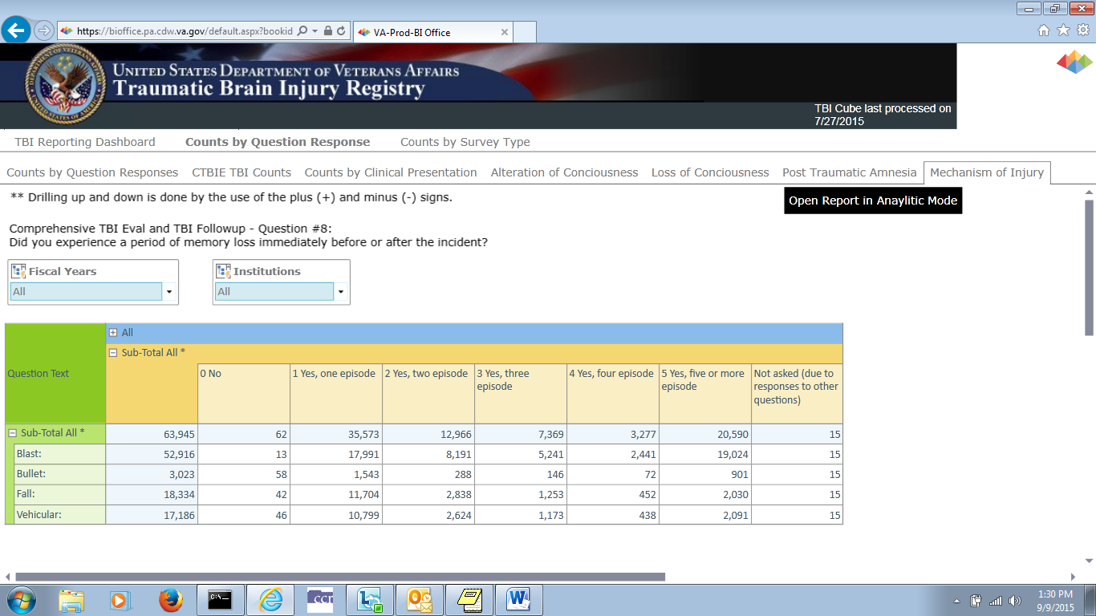

Figure 108 – Mechanism of Injury Counts

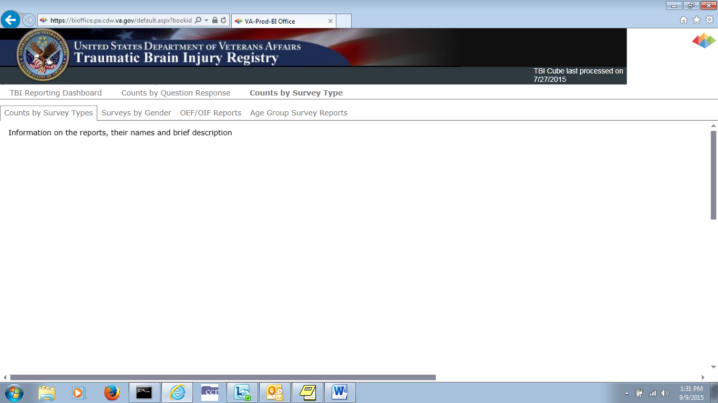

Figure 109 – Counts by Survey Type Report Definitions

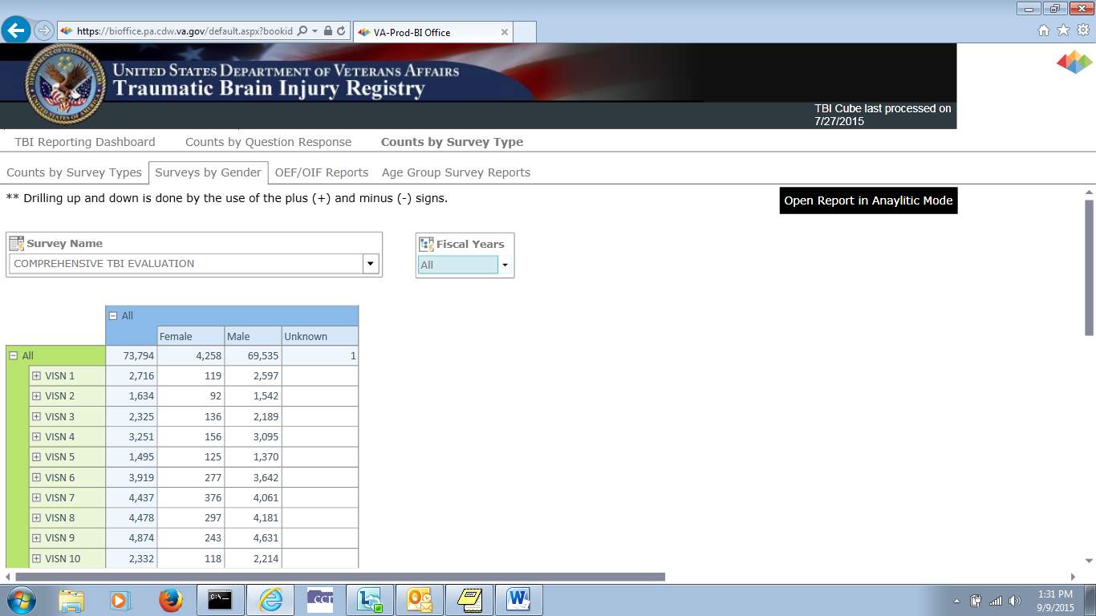

Figure 110 – Surveys by Gender Counts

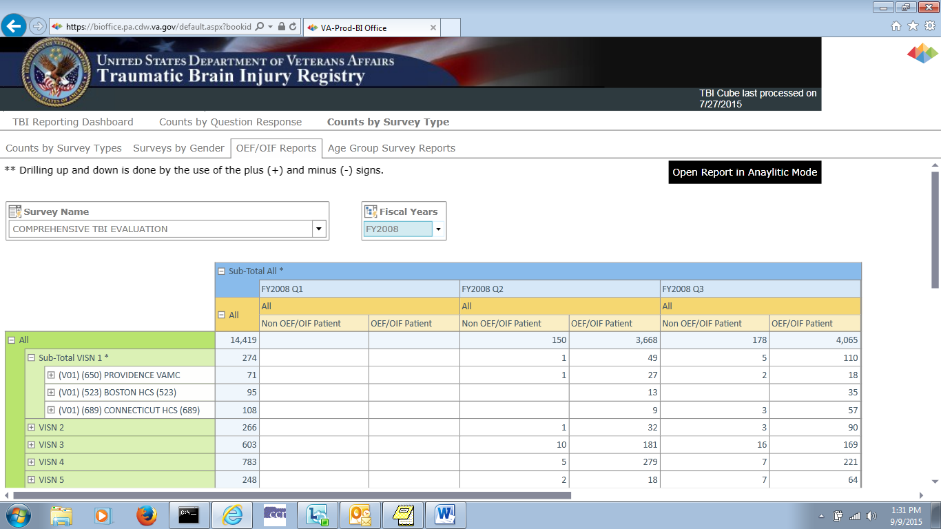

Figure 111 – OEF/OIF Counts

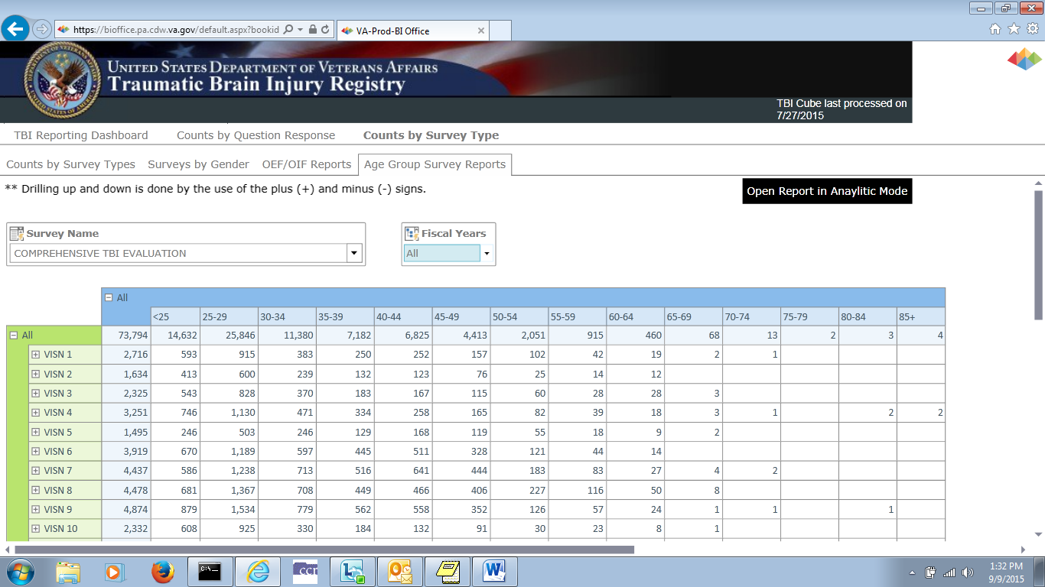

Figure 112 – Surveys by Age Group Counts

1. Business Rules

Certain answer to certain questions, or combination of questions, in the questionnaire skip questions and “jump” to other sections of the evaluation. This section details those questions and their effects on the Comprehensive TBI Evaluation and TBI Follow-up Evaluation Instrument.

* 1. Comprehensive TBI Evaluation Business Rules

Table 3 lists the effect each answer on the Comprehensive TBI Evaluation.

Table 3 – Comprehensive TBI Evaluation Business Rules

| Rule | Description | Related Rules |
| --- | --- | --- |
| CTE BR#1 | Answering Yes to Question A skips all questions until question #27.  Then answering No to question #27 produces no error messages and any other data entered for this instrument is presented in the draft note. | 1. For Question A: Was this evaluation furnished by a non-VA provider, e.g., fee basis? Answer Yes. 2. Question #27: Are the history of the injury and the course of clinical symptoms consistent with a diagnosis of TBI sustained during OEF/OIF deployment? Answer No. |
| CTE BR#2 | Answering Yes to Question A skips all questions until #27.  Then answering Yes to Question #27 produces no error messages and any other data entered for this instrument is presented in the draft note. | 1. For Question A: Was this evaluation furnished by a non-VA provider, e.g., fee basis? Answer Yes. 2. Question #27. Are the history of the injury and the course of clinical symptoms consistent with a diagnosis of TBI sustained during OEF/OIF deployment? 3. Enter Yes for Question #27. |
| CTE BR#3 | Answering No to Question A and selecting None for Question #4 will skip questions:  4-A-1, 4-A-2, 4-B-1, 4-B-2, 4-C-1, 4-C-2, 5-A, 5-B, 5-C, 5-D, 5-D-1, 5-D-1-a, 5-D-2, 5-D-3, 5-D-4, 5-D-5, 5-E, 6, 6-A, 7, 7-A, 8, 8-A, 9, 10, 11, 12, 12-A, 13. | 1. For Question A: Was this evaluation furnished by a non-VA provider, e.g., fee basis? Answer No. 2. For Question #4: How many serious OEF/OIF deployment related injuries have occurred? Answer None. 3. The system skips questions:   4-A-1, 4-A-2, 4-B-1, 4-B-2, 4-C-1, 4-C-2, 5-A, 5-B, 5-C, 5-D, 5-D-1, 5-D-1-a, 5-D-2, 5-D-3, 5-D-4, 5-D-5, 5-E, 6, 6-A, 7, 7-A, 8, 8-A, 9, 10, 11, 12, 12-A, 13   1. Answering Yes in this scenario produces the following message:   In question #4, your response indicates this patient did not experience an OEF/OIF deployment related injury. Based on this response, this patient would not have suffered an OEF/OIF deployment related TBI. If your response to question #4 is not correct, and this patient did experience an OEF/OIF deployment related injury, please make the appropriate correction to question #4, and you will then be permitted to indicate the patient suffered a TBI during OEF/OIF deployment. |
| CTE BR#4 | Answering No to Question A and selecting One for Question #4 will skip questions 4-B-1, 4-B-2, 4-C-1, 4-C-2. | 1. For question A: Was this evaluation furnished by a non-VA provider, e.g., fee basis? Answer No. 2. For Question #4: How many serious OEF/OIF deployment related injuries have occurred? Answer One. 3. The result is:    1. The Year allowed is 2001 to current.    2. The system skips questions:  4-B-1, 4-B-2, 4-C-1, 4-C-2 |
| CTE BR#5 | Answering No to question A and selecting One for question #4 will skip questions 4-C-1, 4-C-2. | 1. For Question A: Was this evaluation furnished by a non-VA provider, e.g., fee basis? Answer No. 2. For Question #4: How many serious OEF/OIF deployment related injuries have occurred? Answer Two. 3. The result is:    1. The Year allowed is 2001 to current.    2. The system skips questions: 4-C-1, 4-C-2    3. If you answered Question #4 with Three, you will be allowed to go to 4-C-1 and 4-C-2 and the Year allowed is 2001 to current. |
| CTE BR#6 | Answering No to Question A and Enter/confirm there is something other than 0.No. Then answering No for question 4, and No for question 5-D will skip questions 5-D-1, 5-D-1-a, 5-D-2, 5-D-3, 5-D-4, 5-D-5. | 1. For Question A: Was this evaluation furnished by a non-VA provider, e.g., fee basis? Answer No. 2. Enter or confirm the answer for Question for is something other than "0. No". 3. For question #5-D. Blast: Answer No. 4. The result is:    1. The system skips questions: 5-D-1, 5-D-1-a, 5-D-2, 5-D-3, 5-D-4, 5-D-5.    2. Answering No on 5-D moves you to question 5-E. |
| CTE BR#7 | Answering No to Question A and Question #6, will skip question 6-A. | 1. For Question A: Was this evaluation furnished by a non-VA provider, e.g., fee basis? Answer No. 2. For Question #6: Did you lose consciousness immediately after any of these experiences? Answer No. 3. The system will skip 6-A |
| CTE BR#8 | Answering No to Question A and answering Uncertain to Question #6, will skip Question 6-A. | 1. For Question A: Was this evaluation furnished by a non-VA provider, e.g., fee basis? Answer No. 2. For Question #6: Did you lose consciousness immediately after any of these experiences? Answer Uncertain. 3. The system will skip question 6-A. |
| CTE BR#9 | Answering No to Question A and Question #7 will skip question 7-A. | 1. For Question A: Was this evaluation furnished by a non-VA provider, e.g., fee basis? Answer No. 2. For Question #7: Did you have a period of disorientation or confusion immediately following the incident? Answer No. 3. The system will skip question 7-A. |
| CTE BR#10 | Answering No to Question A and answering Uncertain to Question #6, will skip Question 7-A. | 1. For question A: Was this evaluation furnished by a non-VA provider, e.g., fee basis? Answer No. 2. For Question #7: Did you have a period of disorientation or confusion immediately following the incident? Answer Uncertain. 3. The system will skip question 7-A. |
| CTE BR#12 | Answering No to Question A and answering Uncertain to Question #8, will skip Question 8-A. | 1. For question A: Was this evaluation furnished by a non-VA provider, e.g., fee basis? Answer No. 2. For Question #8: Did you experience a period of memory loss immediately before or after the incident? Answer Uncertain. 3. The system will skip Question 8-A. |
| CTE BR#13 | Answering No to Question A and Question #12, will skip question 12-A. | 1. For Question A: Was this evaluation furnished by a non-VA provider, e.g., fee basis? Answer No. 2. For Question #12: Prior to this evaluation, had you received any professional treatment (including medications) for your deployment related TBI symptoms? Answer No. 3. The system will skip question 12-A. |
| CTE BR#14 | Answering No to question A and Not at all to Question #17, will skip question 17-A. | 1. For Question A: Was this evaluation furnished by a non-VA provider, e.g., fee basis? Answer No. 2. For Question 17: Overall, in the last 30 days how much did these difficulties (symptoms) interfere with your life? Answer Not at all. 3. The system will skip question 17-A. |
| CTE BR#15 | Answering No to Questions A and #18, will skip questions 18-A, 18-B, 18-C. | 1. For Question A: Was this evaluation furnished by a non-VA provider, e.g., fee basis? Answer No. 2. For Question 18. In the last 30 days, have you had any problems with pain? Answer No. 3. The system will skip questions 18-A, 18-B, 18-C. |
| CTE BR#16 | Answering No to Question A and Not at all to Question #18-B, will skip question 18-C. | 1. For question A: Was this evaluation furnished by a non-VA provider, e.g., fee basis? Answer No. 2. For Question 18-B. In the last 30 days, how much did pain interfere with your life? Answer Not at all. 3. The system will skip question 18-C |
| CTE BR#17 | Answering No to Question A and Not at all to Question #23, will skip Question 23-A. | 1. For question A: Was this evaluation furnished by a non-VA provider, e.g., fee basis? Answer No. 2. For question 23. Psychiatric Symptoms: Answer Not at all. 3. The system will skip question 23-A. |
| CTE BR#18 | Answering No to Question A and select something that does not equal Other condition not related to OEF/OIF deployment related TBI or Behavioral Health conditions(s) for Question #28, will skip Question 28-A. | 1. For question A: Was this evaluation furnished by a non-VA provider, e.g., fee basis? Answer No. 2. For Question 28: In your clinical judgment the current clinical symptom presentation is most consistent with: Answer anything other than Other condition not related to OEF/OIF deployment related TBI or Behavioral Health conditions(s). 3. The system will skip question 28-A. |
| CTE BR#19 | Answering No to Question A and Services will be provided outside VA. to Question #29, will skip questions 29-A, 29-B, 29-C, 29-D, 29-D-1, 29-E, 29-F, 29-G, 29-H, 29-I, 29-I-1, 30. | 1. For question A. Was this evaluation furnished by a non-VA provider, e.g., fee basis? Answer No. 2. For Question 29. Follow up plan: Answer Services will be provided outside VA. 3. The system will skip questions 29-A, 29-B, 29-C, 29-D, 29-D-1, 29-E, 29-F, 29-G, 29-H, 29-I, 29-I-1, 30. |
| CTE BR#20 | Answering No to Question A No services needed to question #29, will skip questions 29-A, 29-B, 29-C, 29-D, 29-D-1, 29-E, 29-F, 29-G, 29-H, 29-I, 29-I-1, 30. | 1. For Question A: Was this evaluation furnished by a non-VA provider, e.g., fee basis? Answer No. 2. For Question 29. Follow up plan: Answer No services needed. 3. The system will skip questions 29-A, 29-B, 29-C, 29-D, 29-D-1, 29-E, 29-F, 29-G, 29-H, 29-I, 29-I-1, 30. |
| CTE BR#21 | Answering No to Question A and Patient refused or not interested in further services to question #29, will skip questions 29-A, 29-B, 29-C, 29-D, 29-D-1, 29-E, 29-F, 29-G, 29-H, 29-I, 29-I-1, 30. | 1. For Question A: Was this evaluation furnished by a non-VA provider, e.g., fee basis? Answer No. 2. For Question 29. Follow up plan: Answer Patient refused or not interested in further services. 3. The system will skip question 29-A, 29-B, 29-C, 29-D, 29-D-1, 29-E, 29-F, 29-G, 29-H, 29-I, 29-I-1, 30. |
| CTE BR#22 | Answering No to Question A and answering something other than Other for Question #29-I, will skip question 29-I-1. | 1. For Question A. Was this evaluation furnished by a non-VA provider, e.g., fee basis? Answer No. 2. For Question 29-I. New medication trial or change in dose of existing medication to address the following symptoms: Answer something other than Other. 3. The system will skip question 29-I-1. |

* 1. TBI Follow-up Evaluation Instrument Business Rules

Table 4 lists the effect each answer on the TBI Follow-up Evaluation Instrument

Table 4 – TBI Evaluation Instrument Business Rules

| Rule | Description | Related Rules |
| --- | --- | --- |
| TFA BR#1 | Answering No to Question #4 will skip Questions 4-A, 4-B, 5-A, 5-B, 5-C, 5-D, 5-D-1, 5-D-1-A, 5-D-2, 5-D-3, 5-D-4, 5-D-5, 5-E, 6, 6-A, 7, 7-A, 8, 8-A, 9, 10, 10-A. | 1. For Question 4: Experienced head injury since prior evaluation? Answer No. 2. The system will skip questions 4-A, 4-B, 5-A, 5-B, 5-C, 5-D, 5-D-1, 5-D-1-A, 5-D-2, 5-D-3, 5-D-4, 5-D-5, 5-E, 6, 6-A, 7, 7-A, 8, 8-A, 9, 10, 10-A |
| TFA BR#2 | Answering No to Question #5-D will skip Questions 5-D-1, 5-D-1-A, 5-D-2, 5-D-3, 5-D-4, 5-D-5 | 1. For question 5-D. "Blast:" Answer No. 2. The system will skip of questions 5-D-1, 5-D-1-A, 5-D-2, 5-D-3, 5-D-4, 5-D-5. |
| TFA BR#3 | Answering No to Question #6 will skip questions 6-A. | 1. For question 6: Did you lose consciousness immediately after any of these experiences? Answer No. 2. The system will skip Question 6-A |
| TFA BR#4 | Answering Uncertain to Question #6 will skip Question 6-A. | 1. For question 6: Did you lose consciousness immediately after any of these experiences? Answer Uncertain. 2. The system will skip Question 6-A |
| TFA BR#5 | Answering No to Question #7 will skip Question 7-A. | 1. For question 7: Did you have a period of disorientation or confusion immediately following the incident? Answer No. 2. The system will skip question 7-A. |
| TFA BR#6 | Answering Uncertain to Question #7 will skip Question 7-A. | 1. For question 7: Did you have a period of disorientation or confusion immediately following the incident? Answer Uncertain. 2. The system will skip question 7-A |
| TFA BR#7 | Answering No to Question #8 will skip Question 8-A. | 1. For question 8: Did you experience a period of memory loss immediately before or after the incident? Answer No. 2. The system will skip question 8-A |
| TFA BR#8 | Answering Uncertain to Question #8 will skip Question 8-A. | 1. For question 8: Did you experience a period of memory loss immediately before or after the incident? Answer Uncertain. 2. The system will skip question 8-A. |
| TFA BR#9 | Answering No to Question #10 will skip Questions 10-A. | 1. For question 10: If you have had a new injury, have you seen any health care providers (doctors/therapists) as a result of the new head injury? Answer No. 2. The system will skip question 10-A |
| TFA BR#10 | Answering Uncertain to Question #8 will skip Question 8-A. | 1. For question 8: Did you experience a period of memory loss immediately before or after the incident? Answer Uncertain. 2. The system will skip question 8-A |
| TFA BR#11 | Answering anything other than Other to Question #20-A will skip Question 20-A-1.  Answer Other on Question #20-A, Question 20-A-1 will appear. | 1. For Question 20-A, answer anything other than "Other". The system will skip Question 20-A-1. 2. For Question 20-A, answer "Other". Question 20-A-1 appears. |
| TFA BR#12 | Answering No to Question #13 will skip Questions 13-A, 13-B | 1. For Question 13: In the last 30 days, have you had any problems with pain? Answer No. 2. The system will skip questions 13-A, 13-B |

1. Glossary

Glossary

|  |  |  |  |  |  |  |  |  |  |  |  |  |
| --- | --- | --- | --- | --- | --- | --- | --- | --- | --- | --- | --- | --- |
| [A](#G_A) | [B](#G_B) | [C](#G_C) | [D](#G_D) | [E](#G_E) | [F](#G_F) | [G](#G_G) | [H](#G_H) | [I](#G_I) | [J](#G_J) | [K](#G_K) | [L](#G_L) | [M](#G_M) |
| [N](#G_N) | [O](#G_O) | [P](#G_P) | [Q](#G_Q) | [R](#G_R) | [S](#G_S) | [T](#G_T) | [U](#G_U) | [V](#G_V) | [W](#G_W) | [X](#G_X) |  |  |
| [0-9](#G_09) |  |  |  |  |  |  |  |  |  |  |  |  |

*Control-click character to see entries; missing character means no entries for that character.*

| Term or Acronym | | | | | Description | |
| --- | --- | --- | --- | --- | --- | --- |
| **0 - 9** | | | | | | |
| 508 | | | *See* [Section 508](#Glos_508) | | | |
| [**BACK**](#G_contents) | to Glossary Contents | | | | | |
| Term or Acronym | | | | Description | | |
| **A** | | | | | |
| ABI | | Acquired Brain Injury | | | | |
| [**BACK**](#G_contents) | to Glossary Contents | | | | | |

| Term or Acronym | | Description |
| --- | --- | --- |
| **B** | | |
| browser | | A program which allows a person to read [hypertext](#Glos_hypertext). The browser provides some means of viewing the contents of nodes (or "pages") and of navigating from one node to another. A browser is required in order to access the TBI software application.  Microsoft® Internet Explorer® and Firefox® are examples for browsers for the World-Wide Web. They act as clients to remote web servers. |
| [**BACK**](#G_contents) | to Glossary Contents | |

| Term or Acronym | | Description |
| --- | --- | --- |
| **C** | | |
| Case | | The collection of information maintained on patients that have been included in a registry. |
| Computerized Patient Record System (CPRS) | | A Computerized Patient Record (CPR) is a comprehensive database system used to store and access patients’ healthcare information. CPRS is the Department of Veterans Affairs electronic health record software. The CPRS organizes and presents all relevant data on a patient in a way that directly supports clinical decision making. This data includes medical history and conditions, problems and diagnoses, diagnostic and therapeutic procedures and interventions. Both a graphic user interface version and a character-based interface version are available. CPRS provides a single interface for health care providers to review and update a patient’s medical record, and to place orders, including medications, special procedures, x-rays, patient care nursing orders, diets, and laboratory tests. CPRS is flexible enough to be implemented in a wide variety of settings for a broad spectrum of health care workers, and provides a consistent, event-driven, Windows-style interface. |
| CPRS | | *See* [Computerized Patient Record System](#Glos_CPRS) |
| [**BACK**](#G_contents) | to Glossary Contents | |

| Term or Acronym | Description |
| --- | --- |
| **D** | |
| Department of Defense (DoD) | A department of the U.S. Federal government, charged with ensuring that the military capacity of the U.S. is adequate to safeguard the national security. |
| DoD | *See* [Department of Defense](#Glos_DoD) |
| [**BACK**](#G_contents) | to Glossary Contents |

| Term or Acronym | | Description | |
| --- | --- | --- | --- |
| **E** | | | |
| [**BACK**](#G_contents) | to Glossary Contents | |

| Term or Acronym | | Description | |
| --- | --- | --- | --- |
| **F** | | | |
| [**BACK**](#G_contents) | to Glossary Contents | |

| Term or Acronym | | | Description | |
| --- | --- | --- | --- | --- |
| **G** | | | | |
| Global War On Terror (GWOT) | | *Obsolete term; see* Overseas Contingency Operation | | |
| GWOT | | Global War On Terror (*obsolete term; see* Overseas Contingency Operation). | | |
| [**BACK**](#G_contents) | to Glossary Contents | | |

| Term or Acronym | | | Description |
| --- | --- | --- | --- |
| **H** | | | |
|  | |  | |
| [**BACK**](#G_contents) | to Glossary Contents | | | |

| Term or Acronym | | | Description | |
| --- | --- | --- | --- | --- |
| **I** | | | | |
|  | |  | | |
| [**BACK**](#G_contents) | | to Glossary Contents | | |
|  |  | | |

| Term or Acronym | | | Description | |
| --- | --- | --- | --- | --- |
| **J** | | | | |
|  | |  | | |
| [**BACK**](#G_contents) | to Glossary Contents | | |

| Term or Acronym | | | Description | |
| --- | --- | --- | --- | --- |
| **K** | | | | |
|  | |  | | |
| [**BACK**](#G_contents) | to Glossary Contents | | |

| Term or Acronym | | | Description | |
| --- | --- | --- | --- | --- |
| **L** | | | | |
|  | |  | | |
| [**BACK**](#G_contents) | to Glossary Contents | | |

| Term or Acronym | | | Description | |
| --- | --- | --- | --- | --- |
| **M** | | | | |
| MAPI | | Mayo-Portland Adaptability Inventory | | |
| [**BACK**](#G_contents) | to Glossary Contents | | |

| Term or Acronym | | Description | |
| --- | --- | --- | --- |
| **N** | | | |
|  | | |  |
| [**BACK**](#G_contents) | to Glossary Contents | | | |

|  |  |  |
| --- | --- | --- |
| Term or Acronym | | Description |
| **O** | | |
| OCO | | *See* [Overseas Contingency Operation](#Glos_OCO) |
| OEF/OIF | | Operation Enduring Freedom/Operation Iraqi Freedom |
| OPCS | | *See* [Patient Care Services](#Glos_PCS) |
| OIT | | Office of Information Technology |
| [**BACK**](#G_contents) | to Glossary Contents | |

| Term or Acronym | | | Description |
| --- | --- | --- | --- |
| **P** | | | |
| Patient Care Services (PCS), Office of | | OPCS oversees VHA's clinical programs that support and improve Veterans' health care. The VA's broad approach to Veteran care incorporates expert knowledge, clinical practice and patient care guidelines in all aspects of care. | |
| [**BACK**](#G_contents) | to Glossary Contents | | |

| Term or Acronym | Description |
| --- | --- |
| **Q** | |

| Term or Acronym | | | Description |
| --- | --- | --- | --- |
| **R** | | | |
| Registry | | The VHA Registries Program supports the population-specific data needs of the enterprise including (but not limited to) the [Defense/Veterans Eye Injury Registry](#Glos_CCR), Oncology Tumor Registry, Traumatic Brain Injury Registry, Embedded Fragment Registry and Eye Trauma Registry.  *Also,* a database containing a collection of data relating to a disease or condition. | |
| [**BACK**](#G_contents) | to Glossary Contents | | | |

| Term or Acronym | | | Description | |
| --- | --- | --- | --- | --- |
| **S** | | | | |
| Section 508 | | Section 508 of the Rehabilitation Act as amended, [29 U.S.C. Section 794(d)](http://frwebgate.access.gpo.gov/cgi-bin/getdoc.cgi?dbname=browse_usc&docid=Cite:+29USC794d), requires that when Federal agencies develop, procure, maintain, or use electronic and information technology, they shall ensure that this technology is accessible to people with disabilities. Agencies must ensure that this technology is accessible to employees and members of the public with disabilities to the extent it does not pose an “undue burden.” Section 508 speaks to various means for disseminating information, including computers, software, and electronic office equipment.  The TBI must be 508 compliant, able to extract data as needed including [SNOMED](#Glos_SNOMED) codes. | | |
| Surveillance | | Systematic collection, analysis, and interpretation of health data about a disease or condition. | | |
| Systematized Nomenclature of Medicine (SNOMED) | | SNOMED is a terminology that originated as the systematized nomenclature of pathology (SNOP) in the early 1960s under the guidance of the College of American Pathologists. In the late 1970s, the concept was expanded to include most medical domains and renamed SNOMED. The core content includes text files such as the concepts, Descriptions, relationships, ICD-9 mappings, and history tables. SNOMED represents a terminological resource that can be implemented in software applications to represent clinically relevant information comprehensive (>350,000 concepts) multi-disciplinary coverage but discipline neutral structured to support data entry, retrieval, maps, etc. | | |
| [**BACK**](#G_contents) | to Glossary Contents | | |

| Term or Acronym | | | Description | |
| --- | --- | --- | --- | --- |
| **T** | | | | |
| TBI | | *See* [Traumatic Brain Injuries](#Glos_TBI) | | |
| Traumatic Brain Injuries (TBI) | | The Traumatic Brain Injuries (TBI) Registry software application allows case managers to identify those Veterans who participated in Operation Enduring Freedom (OEF) or Operation Iraqi Freedom (OIF) and who sustained a head injury and thus are potential traumatic brain injury (TBI) patients. The TBI application permits the case manager to oversee and track the comprehensive evaluation of those patients. It also provides 17 types of reports used for tracking the evaluation and care of individuals identified as possible TBI candidates. | | |
| [**BACK**](#G_contents) | to Glossary Contents | | |

| Term or Acronym | | | Description | |
| --- | --- | --- | --- | --- |
| **U** | | | | |
| Uniform Resource Locator (URL) | | (*Formerly* Universal Resource Locator). A standard way of specifying the location of an object, typically a web page, on the Internet. URLs are the form of address used on the World-Wide Web. In TBI the URL is typically a Web page which displays another application screen. | | |
| URL | | *See* Uniform Resource Locator | | |
| [**BACK**](#G_contents) | to Glossary Contents | | |

| Term or Acronym | | | Description | |
| --- | --- | --- | --- | --- |
| **V** | | | | |
| VA | | *See* [Veterans Affairs](#Glos_VA) | | |
| Veterans Affairs, Department of (VA) | | The VA mission is to serve America's Veterans and their families with dignity and compassion and to be their principal advocate in ensuring that they receive medical care, benefits, social support, and lasting memorials promoting the health, welfare, and dignity of all Veterans in recognition of their service to this Nation.  VA is the second largest Federal department and has over 278,000 employees. Among the many professions represented in the vast VA workforce are physicians, nurses, counselors, statisticians, architects, computer specialists, and attorneys. As advocates for Veterans and their families, the VA community is committed to providing the very best services with an attitude of caring and courtesy. | | |
| Veterans Health Administration (VHA) | | VHA administers the United States Veterans Healthcare System, whose mission is to serve the needs of America’s Veterans by providing primary care, specialized care, and related medical and social support services. | | |
| Veterans Health Information Systems and Technology Architecture (VistA) | | VistA is a comprehensive, integrated health care information system composed of numerous software modules.  *See* [http://www.va.gov/VistA\_monograph/docs/2008VistAHealtheVet\_Monograph.pdf](http://www.va.gov/vista_monograph/docs/2008VistAHealtheVet_Monograph.pdf) and <http://www.virec.research.va.gov/DataSourcesName/VISTA/VISTA.htm>. | | |
| Veterans Integrated Service Network (VISN) | | [VHA](#Glos_VHA) organizes its local facilities into networks called VISNS (VA Integrated Service Networks). At the VISN level, VistA data from multiple local facilities may be combined into a data warehouse. | | |
| VHA | | *See* [Veterans Health Administration](#Glos_VHA) | | |
| VistA | | *See* [Veterans Health Information Systems and Technology Architecture](#Glos_VistA) | | |
| [**BACK**](#G_contents) | to Glossary Contents | | |

| Term or Acronym | | | Description |
| --- | --- | --- | --- |
| **W** | | | |
| WBA | | *See* [Web-Based Application](#Glos_WBA) | |
| Web-based Application (WBA) | | In software engineering, a web application is an application that is accessed via a web browser over a network such as the Internet or an intranet. The term may also mean a computer software application that is hosted in a browser-controlled environment (e.g. a Java applet) or coded in a browser-supported language (such as JavaScript, possibly combined with a browser-rendered markup language like HTML) and reliant on a common Web browser to render the application executable.  Web applications are popular due to the ready availability of web browsers, and the convenience of using a web browser as a client, sometimes called a thin client. The ability to update and maintain web applications without distributing and installing software on potentially thousands of client computers is a key reason for their popularity, as is the inherent support for cross-platform compatibility. Common web applications include webmail, online retail sales, online auctions, wikis and many other functions. The TBI is a WBA.  *See also* [User Interface](#Glos_UserInterface) | |
| [**BACK**](#G_contents) | to Glossary Contents | | |

| Term or Acronym | | | Description |
| --- | --- | --- | --- |
| **X** | | | |
|  | |  | |
| [**BACK**](#G_contents) | to Glossary Contents | | |

1. Web Based Application Elements

The following sections describe typical WBA elements.

Text Box

The appearance of the text boxes change from a plain line border (SAMPLE 1) to an almost three-dimensional, pale yellow-highlighted field when you tab to it or click in it (SAMPLE 2).



Figure 113 - Text Box Sample 1



Figure 114 - Text Box Sample 2

Type your entry into the text box. The entry will not be saved until you tab away from or otherwise exit from the text box. In cases where the format of your entry is important, a sample will appear near the box. The relative width of these boxes is usually a reflection of the number of characters you are allowed to enter. Sometimes (as with date fields) there may also be a “date picker” next to the field.

You should see a “tool tip” pop up when you hover your mouse pointer over the text box.

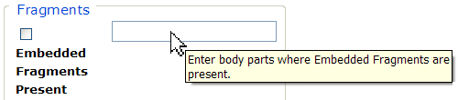

Figure 115 – Tool Tip for Text Box

Checkbox

SAMPLE: 

A checkbox “toggles” (changes) between a YES / NO, ON / OFF setting. It is typically a square box which can contain a check mark  or an “X” ☒ and is usually accompanied by text. Clicking the box or tabbing to the field and pressing the spacebar toggles the checkbox setting. In some instances, checkboxes may be used to provide more than one choice; in such cases, more than one box can be selected. Sometimes, a pre-determined “default” entry will be made for you in a checkbox; you can change the default if needed.

Radio Button

SAMPLE: 

A radio button, also known as an option button, is a small, hollow circle adjacent to text. Radio buttons usually appear in sets, with each button representing a single choice; normally, only one button in the set may be selected at any one time. Clicking on the radio button places a solid dot in the circle, selecting the option. Clicking a selected radio button de-selects it, removing the dot. As one radio button is selected, others within the category switch off. For example, Male or Female may be offered as choices through two radio buttons, but you can only select one of the choices.

Command Buttons

|  |  |
| --- | --- |
| **Command Buttons** | **Description** |
| BUTTON_sEARCH  BUTTON_sAVE | A command button initiates an action. It is a rectangular “3-dimensional” shape with a label that specifies what action will be performed when the button is clicked. Common examples are shown at left. Command buttons that end with three dots indicate that selecting the command may evoke a subsidiary window.  In the text of this document, command button names appear inside square brackets.  *Examples:* [Search], [Save]. |
| Cancel button | The [Cancel] command allows you to cancel the action about to be taken, or to discard changes made on a form. For example, when closing an application, you may be prompted to validate the action to close. If you click the [Cancel] button, the application will not close and you will resume from the point at which the close action was initiated. Or, on a data screen, you may use the [Cancel] button to discard any changes you may have made to the data and close the tab. |
| button_Select | The [Select] command is used to select records for editing. |
| button_Search | The [Search] command is used to find one or more records. When at least one character is typed in a lookup dialog box, clicking the [Search] button will bring up matching entries. In many cases, leaving the lookup box blank will find all such records. Enter the search string and click [Search]**.** Searches are case-insensitive and use “contains” logic. |
| Ok button | The [OK] command is used to accept a default choice, or to agree with performing an action. |

Drop-down List

A drop-down list (sometimes called a “pull-down” list) is displayed as a box with an arrow button on the right side (SAMPLE 1). Such a list allows you to select one item from the list. The current choice (or a prompt) is visible in a small rectangle; when you click on the arrow, a list of items is revealed (SAMPLE 2). Click on one of the entries to make it your choice; the list disappears.



Figure 116 - Dropdown Sample 1

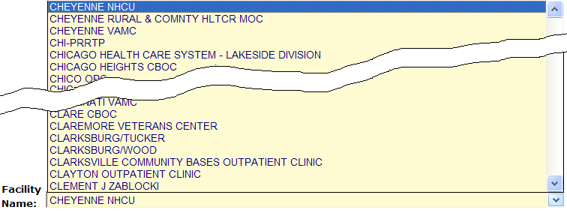

Figure 117 - Dropdown Sample 2